八年级英语上册
期末作文预测 范文拿去借鉴
01、分享经验
假如你是 Sara，在学校的英语竞赛中，你取得了第一名的好成绩。同学们邀请你向他们介绍一下你学习英语的经验。请你根据以下提示，写一篇 70 词左右的短文，给他们提些建议吧！
1. 对学习英语感兴趣；
2. 喜欢听英文音乐和看英文电影；
3. 经常用英语和别人交谈；
4. 喜欢用英语写读后感。
【词汇联想】
1. be interested in... 对……感兴趣
2. try to do sth 尽力做某事
3. be afraid to do sth 害怕做某事
【常用句型】
1. I'm glad to...
2. Why not...?
【参考范文】
Good morning, everyone!
I'm glad to tell you something about my English study. I am very interested in English. Here's some advice for you.
First, listening is very important in learning English. Why not listen to some easy English songs or see English movies every day? Then, try to speak English as much as possible, and don't be afraid to make mistakes. Finally, after you read an English story, you can write something about the story to improve your writing!
02、回复信件
假如你是李琦，昨天你收到了你的美国笔友 David 的来信。在信中他向你介绍了他最喜爱的运动项目—— — 篮球，并且说了他喜爱篮球的原因。请你根据以下提示给他写一封回信，谈一下你对篮球这项运动的看法，以及你最喜爱的运动项目。词数 70 词左右。
1. 篮球是一个不错的运动项目，打篮球可以让人感到兴奋；
2. 你喜欢跑步；
3. 跑步比其他许多运动花钱少，跑步是个令人放松的运动；
4. 你每天早上会跑半个小时的步；
5. 你跑步的时候喜欢听音乐，因为这样可以让你开心。
【词汇联想】
1. favourite sport 最喜欢的运动
2. a relaxing sport 一项令人放松的运动
【常用句型】
It is + adj.+ to do sth. 做某事是……
【参考范文】
Dear David,
Thanks for telling me about your favorite sport — basketball. I think basketball is really a good sport. It is exciting to play basketball. My favourite sport is running. I like running because it's cheaper than many other sports. You just need a pair of comfortable shoes. It is a relaxing sport. I usually spend half an hour running in the park every morning. I always like listening to music when running because it makes me happy. Nothing is more enjoyable than running.
Yours,
Li Qi
03、出行旅游
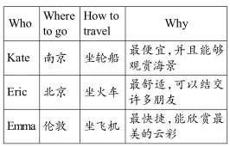
当我们旅游度假时，选择正确的出行方式很重要。几个好朋友正在谈论各自即将到来的假期的出行方式。请根据表格中的内容，以“Different ways to travel”为题写一篇 70 词左右的文章。

【词汇联想】
1. sea views 海景
2. make friends 交朋友
3. take a plane 乘飞机
【常用句型】
1. It's the cheapest way to travel.
2. ...is going to...by...
3. ...would like to take...there.
【参考范文】
Different ways to travel
It's important to choose how to travel. Three friends are talking about their ways to travel.
Kate is going to take a ship to Nanjing. She thinks it's the cheapest way. And she can enjoy sea views on the ship. Eric is going to Beijing by train. He thinks it's the most comfortable way. And he can make lots of friends on the train. As for Emma, she'll go to London. She'd like to take a plane there. She thinks it's the fastest way to travel. And she can enjoy the most beautiful clouds in the sky.
04、网络聊天
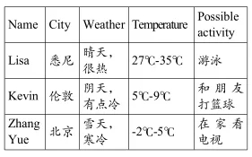
来自不同国家的三位网友正在一个国际聊天室（international chatting room）里谈论各自所在城市的天气情况。请根据下面表格中的内容，写一篇 70 词左右的文章。

【词汇联想】
1. sunny 晴朗的
2. play basketball 打篮球
3. minus 零下
【常用句型】
1. ... comes / is from... ……来自……
2. ... will probably do... ……也许将会做……
【参考范文】
In an international chatting room, three friends are talking about the weather in their cities.
Lisa is from Sydney. It’s sunny and very hot there today. The temperature is between 27℃ and 35℃. She’ll probably go swimming. Kevin is from London.Now it’s cloudy and a bit cold in London. The temperature is between 5℃ and 9℃. He might play basketball with his friends. Zhang Yue lives in Beijing. Now it’s snowy and cold in Beijing. The temperature is between minus 2℃ and 5℃. She may watch TV at home.
05、家乡介绍
假如你是 Cindy，你们学校近期将举行一场以“My home town”为题的写作竞赛。请你根据下面的提示，写一篇文章参赛，介绍你的家乡。70 词左右。
1. 你的家乡是西安，西安位于中国的西北部；
2. 西安有大约 870.56 万人口；
3. 西安历史悠久，有许多名胜古迹，比如秦始皇兵马俑（Terracotta Army）和大雁塔（Giant Wild Goose Pagoda）。
【词汇联想】
1. in the northwest of... 在……的西北部
2. be famous for... 因……而出名
【常用句型】
The population of... is ...
【参考范文】
My home town
I'm Cindy. I'd like to tell you something about my home town — Xi'an. It is in the northwest of China. The population of Xi'an is about 8,705,600. Xi'an has a long history. It is famous for many places of interest, such as the Terracotta Army and the Giant Wild Goose Pagoda.
Every year, many people from all over the world come to visit the famous city.
06、调查报告
假如你是你们校报英语版的小记者，你对八年级同学们的爱好进行了调查，请根据内容提示写一篇英文调查结果。
文中不得出现真实的校名或人名。80 词左右，可适当发挥。
1. 接近半数的学生喜欢听音乐，这样能很好地放松自己；
2. 百分之二十的学生喜欢看书，尤其喜欢看漫画和小说；
3. 大约四分之一的学生愿意做运动，例如徒步、打篮球；
4. 只有百分之五的学生花时间收集东西，例如收集邮票、硬币等；
5. 就我而言，我更喜欢看电影，因为它能在我伤心的时候给我带来快乐。
【词汇联想】
1.hiking 徒步
2.especially 尤其
【常用句型】
1.enjoy doing sth. 意为“喜欢做某事”
2.would like to do sth. 意为“愿意做某事”
【参考范文】
Many students have hobbies. Here is a survey on students’ hobbies in Grade Eight in our school.
Nearly half of the students enjoy listening to music, because it can relax themselves. Twenty per cent of the students like reading books, especially comics and novels. About one fourth of the students would like to do sports, such as hiking and playing basketball. But only five percent of the students spend time collecting things, such as collecting stamps, coins and so on.
As for me, I prefer watching movies, because it can make me happy when I am sad.
07、生活感受
岁月轻轻滑过指尖，许多往事渐渐弥散，但总有一些难忘的故事会印在记忆中。请根据以下提示，以“A special memory”为题写一篇作文和同学们分享一下你的一段特别的忆。
80 词左右，可适当发挥。
1. 第一次公开演讲是在 8 岁的时候；
2. 你害怕出错，但你的老师鼓励你在全校师生面前讲话；
3. 你不想失败，所以努力练习；
4. 演讲开始时很紧张，但你告诉自己可以的，最后成功了；
5. 你明白，如果你能尽自己最大的努力去做每件事情，你就会成功。
【词汇联想】
1.in public 公开
2.fail 失败
【常用句型】
1. be afraid to do sth. 意为“害怕做某事”。
2. try one’s best to do sth. 意为“尽某人最大的努力去做某事”。
【参考范文】
A special memory
I have a fantastic memory. I want to share it with all of you.
I gave my first speech in public when I was at the age of eight. I was afraid to make mistakes but my teacher encouraged me to give a speech in front of the whole school. I didn’t want to fail so I practised a lot. I was nervous at the beginning of the speech. I told myself I could do it and in the end, I was successful.
I learned something from this experience: if you can try your best to do everything, you will be successful.
08、生活日常
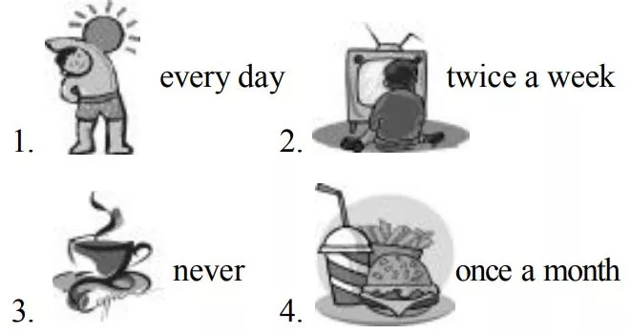
假设你叫 Ben。请根据图片及英文提 示，以“My lifestyle”为题写一篇 70 词左右 的短文，介绍一下自己的日常生活习惯。

【词汇联想】
1.exercise 锻炼
2.homework 家庭作业
3.watch TV 看电视
4.drink coffee 喝咖啡
5.junk food 垃圾食品
【常用句型】
in good health 身体健康
I never ... 我从不……
I think ... 我认为
【参考范文】
My lifestyle
I’m Ben. I’m a middle school student. I exercise every day, and I’m in good health now. I have a lot of homework to do every evening, so I don’t have time to watch TV from Monday to Friday. I just watch TV twice a week, on Saturday and Sunday evenings. I never drink coffee, but I like eating junk food. However, my mom says junk food isn’t good for my health, so I only eat it once a month. I think my lifestyle is healthy.
09、旅游推荐
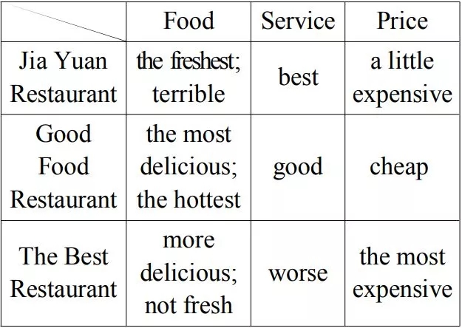
假设你是 Sally，你的朋友 Anna 下周 想来你们镇上旅游，想让你推荐一家比较 好的餐馆。请根据下表信息进行简单介绍。 70 词左右。

1.首先，简单介绍镇上有三家有名的餐馆；
2.其次，根据提示写出三家餐馆的对比情况；
3.最后，表达自己期盼朋友能够喜欢镇上的食物。
【词汇联想】
1.restaurant 饭馆
2.taste 品尝
3.service 服务
4.enjoy 愉快
5.hope 希望
【常用句型】
There are ...这里有
【参考范文】
There are three restaurants in our town. Jia Yuan Restaurant has the freshest food but it tastes terrible. And the food is also a little expensive. But it has the best service. The food in Good Food Restaurant is the most delicious but the hottest of all. The service in it is good. And the food is also cheap. The Best Restaurant has more delicious food than the other two but it is not fresh. And the service in it is worse. The worst of all, its food is the most expensive. I hope you can enjoy the food in our town.
10、动漫介绍
假设你是 Peter，你打算今晚看一部动漫。请根据下面的提示，写一篇短文，向大 家介绍一下你要看的这部动漫。70 词左右。
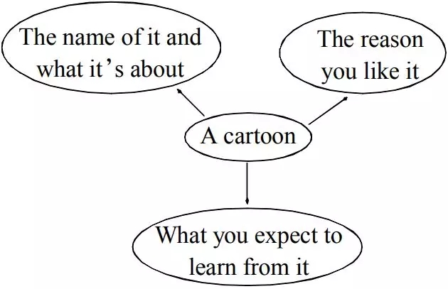

1.首先，简单介绍你要看的动漫名字及它是关于什么的；
2.其次，你喜欢它的原因；
3.最后，你期盼从这个动漫中学到什么。
【词汇联想】
1.watch 看
2.cartoon 卡通
【常用句型】
1.want to ... 想做……
2.because it is ... 因为它……
3.is about ... 关于……
4. I can learn ... 我可以学到……
【参考范文】
My name is Peter. I want to watch a cartoon tonight. Its name is Princess Mononoke. It is a cartoon that can make me think. The cartoon is about a beautiful girl, San and a village boy, Ashitaka. They together with animals fight with people to protect the nature. I like watching Princess Mononoke because it is more educational and wonderful. I can learn to love nature from the cartoon.

