九年级中考【一模】试题
【英语】
班级： 姓名： 分数： .
一、单项选择
1.May 10,2017 was marked as ________ first Chinese Brands Day(中国品牌日). “Made in China” has come of age.
A. a B. an C. the D.不填
2. The young mother won't leave her baby _______ she is sure that he has already been asleep.
A. unless B. because C. if D. since
3. — Do you enjoy the songs sung by Jay Chou?
— Of course. Not only I but also my parents ________ his fans.
A. am B. are C. was D. were
4. Which of the following words is pronounced /raiz/ ?
A. race B. ride C. rose D. rise
5.China's first home-built aircraft carrier(航空母舰) hit the water in Dalian _______ the morning of April 26, 2017.
A. in B. on C. at D. to
6. I was told that a new road would be built to _______ my hometown to Zhenjiang.
A. compare B. contact C. commit D. connect
7. All the drivers_______ reduce speed when driving near the zebra crossing.
A. can B. can't C. must D. mustn't
8. Xu Yuanchong, a 96-year-old man, devotes most of his lifetime to _______ works of literature.
A. translate B. translates C. translating D. translated
9. The Belt and Road(一带一路) will serve to _______ markets for China and other countries along.
A. open up B. put up C. make up D. look up
10. — I hear you're crazy about Roger Federer.
— Exactly. He is one of the greatest tennis players in the world and _______ 18 grand slams(大满贯) all together.
A. Achieves B. achieved C. has achieved D. will achieve
11.— Our monitor, Lin Tao, keeps all his things in
good order.
— That's true. He's so _____, and we should learn from him.
A. creative B. generous C. modest D. organized
12. Last December, a man who stole a shared bike ____ 1,000 yuan by the police.
A. fined B. was fined C. will be fined D. has fined
13. — You look tired. What's wrong with you?
— I stayed up late last night. I _______ my speech from eight o'clock to midnight.
A. Practiced B. am practicing
C. was practicing D. has practiced
14. — To London? Don't miss red phone boxes in the
streets. They're a symbol of English culture.
— _______.
A. Thanks for your advice B. hope so
C. Sorry, I don't know D. Thank you all the same
15. — How is your May Day holiday, John?
— Not bad. You seem so happy. Could you tell me _______?
A. what place you have been to
B. if you visit your grandparents
C. who did you spend the holiday with
D. that you watched a football match

二、完形填空
As a kid, I used to spend my summers with my grandparents on their farm in Texas. I helped them with farming at times. Luckily, they a caravan, a kind of car designed for people to live in while travelling. Every few summers, we'd travel together around the US and Canada.
On one trip, I was about 10 years old. I was playing around in the back of the car my grandfather was driving. My grandmother had the passenger seat. She smoked through the trip, and I hated the , which made me cough a lot. I read about smoking in an article. It says that every puff(吸) of a cigarette takes two minutes off your life. I the number of cigarettes per day and the puffs per cigarette. When I came up with a reasonable(合理的) number, I was . Then I moved my head into the front of the car and proudly , "So far, you've taken nine years off your life!" Hearing this, my grandmother began to cry and it was not what I . I did not know what to do. My grandfather, who had been driving , stopped the car, got out of it and opened my door. He looked at me calmly, and said , "See, grandmother is crying! One day, you'll understand that it's harder to be kind than clever."
As I grow up, I realize that cleverness is a gift and kindness is a choice. Gifts are easy — they are given . Choices can be hard, so it seems more difficult to be kind.
1.A: produced B: owned C: required D: returned
2.A: as B: when C: while D: though
3.A: dust B: taste C: noise D: smell
4.A: guessed B: counted C: collected D: received
5.A: afraid B: relaxed C: satisfied D: worried
6A: replied B: explained C: presented D: announced
7.A: dreamed B: enjoyed C: supported D: expected
8.A: in fear B: in silence C: with pride D: with sadness
9.A: gently B: loudly C: powerfully D: confidently
10.A: in all B: after all C: above all D: first of all

三、阅读理解
A
When meeting strangers, we usually notice their hair, skin colour and clothes. We like to group those things we don't know by comparing them with the things we know.
So what's wrong with this? For example, we think that short boys can't possibly be good basketball players. The girls who love to be dressed up can't be excellent students. Or we think shy students can't be good at giving speeches. These are typical(典型的) examples of stereotypes.
Stereotypes make people form a wrong opinion about others at first sight. In fact, it takes a lot more than just looking at a person to know and understand him or her. The following is my story.
One day, it was snowing, but not very heavily. Before class, I collected all the exercise books and sent them to the teachers' office. The exercise books looked piles in my arms, so I could hardly see the ground. Suddenly, I slipped over(滑倒) and dropped all the exercise books I was carrying.
I tried to stand up but failed, I was about to pick them up when I saw a boy coming towards me. It was Mike.
Mike and I had been classmates for over 2 years, but we had never shared more than 5 sentences together. He was a boy with few words, but I liked talking. We were totally different. I didn't like him and didn't want to be seen at that moment.
"Anything serious?" His words brought me out of my thoughts. "I saw you sitting on the ground from the back window, so I rushed here. Let me help you!" He helped me up and picked all the exercise books up.
Seeing this, I was so moved that I couldn't say a single word.
We walked towards the teachers' office and this time, he talked a lot to me. I found quite a different Mike.
I took a deep breath and said to myself, "I nearly made a big mistake — judging(判断) MIke only by his appearance."

1. Which of the following is NOT mentioned as typical examples of stereotypes?
A: Dishonest children can't be others' true friends.
B: Shy students can't be good at giving speeches.
C: Short boys can't possibly be good basketball players.
D: The girls who love to be dressed up can't be excellent students.
2. Why did the writer dislike Mike at the beginning?
A: Because the writer didn't know Mike at all.
B: Because Mike didn't hand in his exercise book.
C: Because the writer thought they weren't the same type.
D: Because Mike didn't help the writer collect the exercise books.
3. The writer probably wants to tell us _______.
A: we'd better not go outside on snowy days
B: we should get along well with our classmates
C: people shouldn't judge someone at first sight
D: people with different personalities can't be friends

B
The Diary of a Young Girl was written by a girl named Anne Frank. It is a true experience of a teenager in wartime(World War II, 1939—1945) and it has also become a symbol of the victory of the human spirit.
Here's one of Anne's diaries.

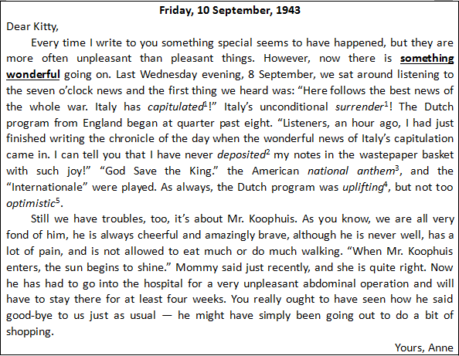

1. The underlined phrase "something wonderful" refers to(指代) that _______.
A: Anne's family could listen to news
B: Italy capitulated
C: the Dutch program was uplifting
D: Mr. Koophuis was cheerful
2. What is the most probable date that Mr. Koophuis returned from hospital?
A: 10 September. B: 24 September.
C: 3 October. D: 17 October.
3. Which of the following is probably NOT true according to the passage?
A: Anne often faced unpleasant things.
B: Anne's family got news on radio.
C: Mr. Koophuis was welcome in Anne's family.
D: Mr. Koophuis was quite afraid of his operation.

C
Have you ever wondered how we know the things that we know? How do we know, for example, that the stars are really huge balls of fire like the Sun and very far away? And how do we know that the Earth is a smaller ball turning round one of those stars, the Sun?
The key to these questions is "evidence", which means the facts, signs or objects that make you believe something is true.
Sometimes evidence means actually(实际地) seeing(or hearing, feelings, smelling ...) that something is true. Astronauts have travelled far enough from the Earth to see with their own eyes that it is round. Sometimes our eyes need help. The "evening star" looks like a bright twinkle in the sky, but with a telescope(望远镜) you can see that it is a beautiful ball. Something that you learn by direct seeing(or hearing or feeling ...) is called an observation.
Often evidence isn's just observation on its own, but observation always hides at the back of it. If there's been a murder, often nobody(except the murderer and the dead person!) actually observed it. But detectives can gather together lots of other observations which may all point towards the suspect. If a person's fingerprints match those found on a knife, this is evidence that he touched it. It doesn't prove that he did the murder, but it can help when it's joined up with lots of other evidence.
Prediction(预测) helps to look for evidence. Scientists make a guess about what might be true. For example, if the world is really round, we can predict that any of us, going on and on in the same direction, should eventually find ourselves back where we started.
People sometimes say that you must believe in feelings deep inside, but not all the inside feelings are real evidence.
What can we do about all this? When somebody tells you something that sounds possible, think to yourself: "Is there any evidence for that?" And, next time somebody tells you that something is true, why not say to them: "What kind of evidence is there for that?" Remember, always think carefully before you believe a word.

1. Which of the following is TRUE according to the passage?
A: What you see directly is real evidence.
B: Prediction helps to prove something if it is true.
C: People should always believe their inside feelings.
D: Astronauts find the Earth is round with a telescope.
2. Why does the writer use the example of a detective in Paragraph 4?
A: To explain what prediction is.
B: To tell what observation is called.
C: To introduce how detectives work.
D: To prove evidence is not just observation.
3. The underlined word "eventually" in Paragraph 5 means _______.
A: finally B: probably C: completely D: luckily
4. What's the best title of the passage?
A: Evidence speaks
B: Scientists make predictions
C: Inside feelings help get ideas
D: Observation offers the facts

四、词汇运用
A.根据括号内所给单词的正确形式填空
The boy and his father and go_____(swim) every weekend.
Young people working at Shanghai Disneyland are getting _____(busy)as more tourists visit the park.
Many famous ______(director) wives appeared at the film festival with their husbands.
With the ______(develop) of Xiong’an New Area, more than 180,000 jobs can be provided for local people.
Nick’s mother worries about his _____(healthy) lifestyle, though he is a collage student.

B.根据句意或汉语提示写出各单词的正确形式
The dentist suggest that the girl should brush their _______(牙齿）before going to bed.
The boy threw the ball to the dog and it _____(接住，捉住）the ball successfully.
When Mr. Jiang got up in the morning, his suit was ironed ________(平整地）by the robot.
In the first half of the year, there was ______(四十）twins among all the new born babies in that hospital.
---Where is the city museum?
---It’s ______(在...对面）the front gate of the Grand Hotel.

五．短文填空
One day, when a boy named Ted returned from school in a hurry, his mother complained, "It is six o'clock, and your school c at four — where have you been?""Oh, mom," said Ted, "when we play ball games, we f everything else. We don't think of the time. Is supper ready?"
The boy's mother believed him. Ted's a led her to think that he had been playing with his classmates. But he hadn't been playing at all.
He had been "kept in" by the school librarian, because he had made the l in a complete mess. He didn't like to tell his mother about that. He wished her to think that he had been playing."What a s it is for you to try to deceive(欺骗) your mother!" said something in Ted's heart, as he q sat down to his supper.
"I don't care," said the boy to h . "I don't care. I didn't tell a lie — I didn't say that I was playing."
"But," said the voice, "you used words which m your mother think that you had been playing, and that was s to what you had said so."
"I didn't tell a lie." said Ted.
Did Ted tell a lie, or did he not? What do you think?
If we use words which can deceive others, we tell a lie; and Ted's lie was a bad one, for it sounded so like the t . A lie that sounds true is the worst kind of lie.

六、任务型阅读
A
Some people have found that they always spend much more on travelling than planned. Here is how it happens:
1. Preparing too much before travelling
Some people, especially females, like to travel as if starting a new life. Several weeks before the trip, they would be busy shopping for new dresses, better sunglasses and best-selling books. They would rather fill their travelling bags up with all fashionable things. Just travelling? Attending a fashion show more like it. They care more about their appearance than the sights they see during the trip.
2. Following other travellers blindly
They can't stop shopping for objects they would never normally buy and would certainly never use. For example, we can find a group of travellers "getting ahead" to buy "Christmas" presents even in summer.
3. Replacing things that are forgotten to bring
They don't remember to bring things like trainers, cool bags, toothbrushes or beach towels. The towels sold near beaches are nearly the price of gold leaves. They spend a lot on those things. However, plenty of new towels are sleeping in their bathroom at home.

阅读以上信息，用恰当的单词完成下面的短文，每空一词。
People usually find themselves poorer than they planned after a holiday trip. There are mainly three . Firstly, some female travellers consider a journey as attending a fashion show. How they look seems more than what they see, so they spend more money on something new. Secondly, some people follow others without . When others do some shopping, they can't themselves. Thirdly, goods for daily use at tourist attractions aren't as as those back home. As a result, they may spend more than they thought.
B
Giving up studying in China's top universities is truly surprising. It's reported that two young people dropped out of Tsinghua University after they found they had no interest in their majors(专业). They took the CEE(college entrance examinations) again. Luckily, they passed the exams and studied new majors in Peking University. Their actions have come under hot discussion among the public.
Supporters praise the two students for being brave enough to chase(追逐) their goals.
1. We shouldn't blame(责怪) those who are willing to take a risk and take the CEE again. It's OK for everyone to choose their favourite major for a better career in the future.
2. The two students prove that life is full of changes and possibilities. They set up an example of the power of courage in changing lives.
However those who are against their actions criticize them for being capricious(任性的).
1. By dropping out after studying for a period of time, the two students have wasted educational resources, which could have been provided for others.
2. The two students were not wise enough to choose their majors when they first applied to go to college. Their actions should be a warning to other young people instead of being followed.
阅读以上信息，用恰当的单词完成下面的表格，每空一词。
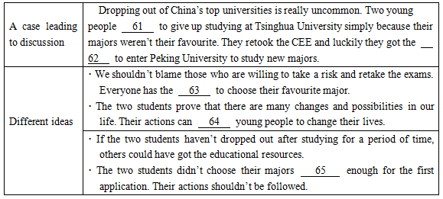

61____________62____________63____________64____________ 65____________

七、书面表达
假如你是李华，父母支持你邀请笔友 David 来你家共度暑假，并带给你一份青少年活动中心（the Youth Centre）七月份的活动安排表。请根据要求完成一封邀请信，向 David 介绍你的安排。
要求：
1. 所写内容必须包括以上表格提供的所有信息，并适当发挥。
2. 文章不少于90词，开头和结尾已给出，不计入总词数。
3. 语意顺畅，意思连贯，条理清楚，书写规范。
4. 文中不得出现真实的姓名、校名等信息。
参考词汇：
perform v. 表演； Chinese painting n. 国画； appreciate v. 鉴赏
附：
青少年活动心暑期活动安排表
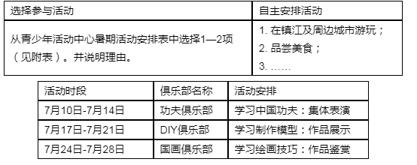

Dear David,
How are you going? Summer holiday is coming. My parents support me to invite you to spend the holiday with me.
__________________________________________
__________________________________________
__________________________________________
I'm looking forward to your coming soon.
参考答案
单选、1-5 CABDB 6-10 DCCAC 11-15 DBCAA
完型、16-20 BCDBC 21-25 DDBAB
阅读理解、26-28 ACC 29-31 BDD 32-35 BDAA
词汇运用、36.swimming 37.busier 38.directors’ 39.development 40.unhealthy
41.teeth 42.caught 43.smoothly 44.forty 45.opposite
短文填空、46.closes 47.forget 48.answer 49.library 50.shame
51.quietly/quickly 52.himself 53.made 54.similar 55.truth
任务型、 56.resons/causes 57.important 58.thinking 59.control 60.cheap
61.chose/decided 62.chance 63.right 64.encourage 65.wisely
66.【参考范文】
Hi David,
How are you going? Summerholiday is coming. My parents support me to invite you to spend theholiday with me.Here are some activities that we can take part in.
There is a Youth Centre withthree clubs in our city. From July 10th to 14th, we can join theChinese Kung Fu Club if you want to learn Chinese Kung Fu. If youlike DIY, you can join DIY Club from July 17th to 21st, and you canlearn to make models show them to others there. Chinese Painting isalso very famous.Wecan learn the skills of paintings and enjoyworks in the Chinese Painting Club between July 24th and 28th. Whichclub would you like to join? You can choose one or two of themaccording to your hobbies.Ithink you can have a great time here.
I’m looking forward toyour coming soon.

