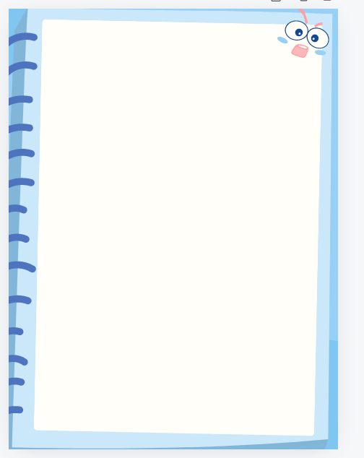
七年级英语 | 完形填空阅读理解
【时间管理的重要性】
一：The Importance of Time Management for Students
As a student, managing your time effectively is crucial to achieving academic success. Time management helps you (1) _____ your daily tasks and responsibilities without feeling overwhelmed. It allows you to focus on your studies (2) _____ getting distracted by other activities. By creating a schedule, you can (3) _____ your study hours and ensure that you have enough time for each subject. Good time management also means taking breaks when needed, which can help you stay (4) _____ and avoid burnout. Remember, time is a precious resource that, once wasted, cannot be (5) _____.
（1）A. balance B. ignore C. avoid
答案：A
解析：时间管理帮助学生平衡日常任务和责任，因此应选“balance”（平衡）。
（2）A. instead of B. in addition to C. as well as
答案：A
解析：时间管理让学生能专注于学习而不是被其他活动分散注意力，因此应选“instead of”（而不是）。
（3）A. allocate B. reduce C. increase
答案：A
解析：通过制定时间表，学生可以分配学习时间，因此应选“allocate”（分配）。
（4）A. focused B. relaxed C. entertained
答案：A
解析：良好的时间管理包括在需要时休息，这有助于学生保持专注，因此应选“focused”（专注的）。
（5）A. regained B. recovered C. retrieved
答案：A
解析：时间一旦浪费就无法重新获得，因此应选“regained”（重新获得）。

二：Mastering Time Management for a Balanced Life
In today's fast-paced world, mastering time management is essential for maintaining a balanced life. It helps you prioritize your tasks and (1) _____ your energy where it's most needed. By setting clear goals and deadlines, you can stay on track and avoid procrastination. Effective time management also involves learning to say no to activities that don't align with your goals, allowing you to focus on what's truly (2) _____. Additionally, taking time for self-care, such as exercise and relaxation, is crucial for maintaining a healthy work-life (3) _____. Remember, managing time well is not just about being busy; it's about being (4) _____ and productive. By making conscious choices about how you spend your time, you can create a life that is both fulfilling and (5) _____.
（1）A. conserve B. distribute C. expend
答案：B
解析：时间管理有助于你将精力分配到最需要的地方，因此应选“distribute”（分配）。
（2）A. important B. enjoyable C. trivial
答案：A
解析：有效的时间管理让你专注于真正重要的事情，因此应选“important”（重要的）。
（3）A. balance B. harmony C. rhythm
答案：A
解析：自我照顾对于维持健康的工作与生活平衡至关重要，因此应选“balance”（平衡）。
（4）A. efficient B. energetic C. enterprising
答案：A
解析：良好的时间管理不仅仅是忙碌，而是高效和富有成效，因此应选“efficient”（高效的）。
（5）A. stressful B. rewarding C. demanding
答案：B
解析：通过有意识地选择如何花费时间，你可以创造一个既充实又值得的生活，因此应选“rewarding”（值得的）。
三：Time Management Techniques for Busy Professionals
Busy professionals often struggle to find enough time for work, family, and personal interests. Effective time management techniques can help. One technique is to use a planner or digital calendar to (1) _____ appointments, deadlines, and important tasks. Another strategy is to break down large projects into smaller, manageable tasks, making them less (2) _____ and more achievable. Setting priorities is also key. Identify which tasks are most critical and tackle them first. Lastly, learn to delegate tasks that can be done by others, freeing up your time for tasks that require your unique (3) _____. Remember, effective time management is not about doing everything yourself; it's about (4) _____ your time and resources wisely. By adopting these techniques, busy professionals can lead a more (5) _____ and organized life.
（1）A. track B. cancel C. postpone
答案：A
解析：使用计划本或数字日历来跟踪约会、截止日期和重要任务，因此应选“track”（跟踪）。
（2）A. overwhelming B. interesting C. enjoyable
答案：A
解析：将大型项目分解为较小的、可管理的任务，使它们不那么令人难以承受且更易实现，因此应选“overwhelming”（令人难以承受的）。
（3）A. skills B. time C. energy
答案：A
解析：学会将任务委托给他人，以便将时间用于需要独特技能的任务上，因此应选“skills”（技能）。
（4）A. saving B. wasting C. using
答案：C
解析：有效的时间管理不仅仅是自己做所有事情，而是明智地使用你的时间和资源，因此应选“using”（使用）。
（5）A. chaotic B. fulfilling C. isolated
答案：B
解析：通过采用这些技巧，忙碌的专业人士可以过上更加充实和有条理的生活，因此应选“fulfilling”（充实的）。

