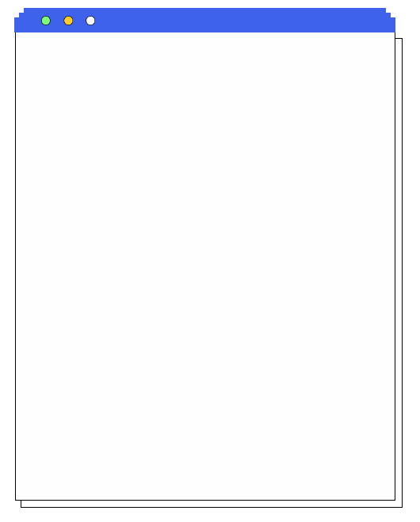
2024新人教版 | 七上英语期末复习专练
【完形填空】过关练习

This boy's name is___1___ . He___2___twelve. This is ___3___school.___4___teacher is Miss Yang.___5___a good teacher. Jim has___6___good friend___7___school. His name ___8___Zhang Lin. They're___9___Class 2, Grade 7. They are the best students in___10___class.
（A）1. A. Jim Green B. Green Jim C. Jim green D. Green jim
（B）2. A. am B. is C. are D. be
（C）3. A. he B. him C. his D. he's
（D）4. A. He B. Him C. He's D. His
（A）5. A. She's B. She C. Her D. He
（C）6. A. the B. / C. a D. an
（C）7. A. to B. on C. at D. /
（B）8. A. are B. is C. be D. am
（D）9. A. at B. on C. to D. in
（D）10. A. these B. they C. they're D. their
2024新人教版 | 七上英语期末复习专练
【完形填空】过关练习

1 is my family photo, you can see 2 people, my father, mother, brother and me. This is 3 father. 4 name is Jack Brown. His jacket is 5 . This is my 6 , Mary Brown. The 7 is my brother. 8 name is Nick Brown. The girl in the picture is me. 9 am Jennifer Brown. My 10 is very happy.
（B） 1. A. here B. this C. Here
（A） 2. A. four B. three C. six
（A） 3. A. my B. his C. her
（B）4. A. My B. His C. Her
（A） 5. A. black B. yellow C. white
（A）6. A. mother B. aunt C. uncle
（B）7. A. girl B. boy C. uncle
（A） 8. A. His B. Her C. Its
（A）9. A. I B. He C. She
（B） 10. A. school B. family C. sister
2024新人教版 | 七上英语期末复习专练
【完形填空】过关练习

My name is Mary. I have __1__ clothes. I like __2__ very much. This is my skirt. __3__ blue. I buy it __4__ Zig Zag’s Clothes store. It’s 18 __5__. Please look at my _6__. They are red. __7__ only 40 ___8__. 10. I buy __9__ from Huaxing clothes store. They __10_nice. I like them very much.
（B）1. A. lot of B. lots of C. a lot
（C）2. A. it B. they C. them
（A）3. A. It’s B.It C. They
（A）4. A. from B. on C. to
（B）5. A. dollar B. dollars C. yuans
（C）6. A. trouser B. a trouser C. trousers
（B）7. A. They B. They’re C. It
（C）8. A. ＄ B. dollar C. yuan
（C）9. A. they B.it C. them
（A）10. A. look B. looks C. watch

2024新人教版 | 七上英语期末复习专练
【完形填空】过关练习

Frank and Bill 1 a good friend. His 2 name is Paul. They like sports. Frank thinks baseball 3 interesting . He 4 it .Bill and Paul like playing tennis. They have a pair of 5 .Tennis 6 relaxing. They 7 play soccer, because it’s difficult. Frank and Paul 8 watch TV because it is boring .Frank and Bill 9 volleyball. They often 10 to play volleyball on the playground.
（C）16. A. have B. has C. are D. is
（D）17. A. family B. friend’s C. last D. first
（A）18. A. is B. are C. has D. have
（B）19. A. play B. likes C. like D. plays
（C）20. A. tennises rackets B. tennis racket
C. tennis rackets D. tennises racket
（C）21. A. have B. has C. is D. are
（A）22. A. don’t B. aren’t C. / D. can
（A）23. A. don’t B. aren’t C. / D. can
（C）24. A. have B. has C. like D. plays
（C）25. A. to go B. goes C. go D. going
2024新人教版 | 七上英语期末复习专练
【完形填空】过关练习

Look at the photo. It's my family. The old man and the old woman are my grandparents. They like 1 TV. This is my father. He is next to his brother, my 2 . This woman is my mother. You can 3 three children in the photo. The two girls are my sisters. We often play sports because it's 4 for us. The girl in a purple dress is Cindy 5 the girl in a yellow dress is Anna. Do you know who the boy is? It's me. My grandparents live in the U.S.A. I live in Beijing 6 my parents now. My father is a 7 . He works in Beijing No. 2 Middle School. He often has milk 8 breakfast. And he likes to eat 9 . My mother is a teacher, too. She often has eggs and milk. She doesn't want 10 fat. What about you?
（B）1. A. look B. looking C. watching D. watch
（B）2. A. aunt B. uncle C. sister D. brother
（C）3. A. see B. ask C. call D. look at
（B）4. A. boring B. difficult C. healthy D. well
（D）5. A. and B. but C. or D. so
（A）6. A. and B. of C. for D. with
（C）7. A. student B. driver C. farmer D. teacher
（B）8. A. for B. to C. in D. on
（D）9. A. a bread B. some chickens C. a chicken D. bread
（D）10. A. be B. to be C. to do D. do

