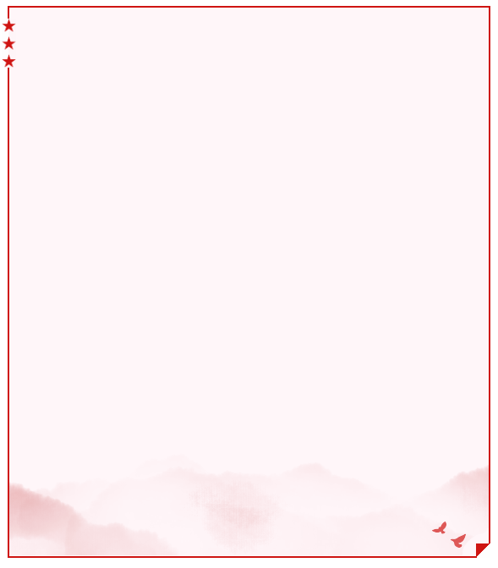
七年级英语上册 | 期末复习专练
【完形填空】拔高训练
【一】
Hi！I 1 Jimmy Brown. Jimmy is my 2 name and Brown is my last name. I am 3 English boy. Gina is 4 microblog friend. 5 last name is Brown. 6 is her QQ number? Oh， it's 8546688. She is 7 China now. She studies in Yucai Middle 8 . Look at the classroom of the English club (俱乐部). There is a clock on the wall (在墙上). It's 6:00 now. What's this? It's a pen. What's that? It's a ruler. 9 pen and the ruler 10 blue. This is a computer. We often learn (学习) English in the classroom.
（A）1. A. am B. is C. are D. be
（A）2. A. first B. last C. middle D. full
（B）3. A. a B. an C. the D. /
（D）4. A. I'm B. his C. her D. my
（B）5. A. She B. Her C. He D. His
（B）6. A. What color B. What C. How D. What's
（C）7. A. to B. for C. in D. at
（D）8. A. Name B. China C. Number D. School
（C）9. A. A B. An C. The D. /
（C）10. A. am B. is C. are D. /
七年级英语上册 | 期末复习专练
【完形填空】拔高训练
【二】
Mr. Jones is our science(科学) teacher. 1 class is very interesting. We can learn a lot 2 his class. We love him very 3 . He often tells us some strange things and 4 us to make things. Now some of us make many different kinds of things 5 model boats and robots(机器人).
Mrs. Jones is our music teacher. She teaches us 6 to sing. She can 7 the violin and the piano. She can dance very 8 . Mr. Jones is very strict(严格的) with us. But Mrs. Jones is very kind 9 us. They are good 10 and we love them.
（C）1. A. She B. Her C. His D. He
（B）2. A. with B. from C. for D. behind
（D）3. A. nice B. well C. good D. much
（A）4. A. teaches B. takes C. makes D. gives
（B）5. A. on B. like C. under D. in
（A）6. A. how B. why C. where D. what
（D）7. A. buy B. put C. get D. play
（C）8. A. good B. fine C. well D. bad
（B）9. A. for B. to C. with D. about
（C）10. A. friends B. students C. teachers D. doctors
七年级英语上册 | 期末复习专练
【完形填空】拔高训练
【三】
I'm a middle school student. My first name is Lisa and my 1 name is Green. I'm 12 years old. I have 2 good friends. One is 3 boy. His name is Tom. The other (另一个) is a girl and 4 name is Alice. Tom 5 13. His birthday is on July fifteenth. Alice is 12 years old. 6 is her birthday? Oh, 7 on December twelfth. She always has a birthday 8 at home on that day and has a good 9 . What about me? My birthday is on January 10 , New Year's Day.
（C）1.A. middle B. nice C. last D. small
（A）2.A. two B. three C. four D. five
（A）3.A. a B. an C. the D. 不填
（B）4.A. his B. her C. my D. your
（A）5.A. is B. are C. has D. have
（D）6.A. How B. Who C. Why D. When
（C）7.A. he's B. she's C. it's D. I'm
（C）8.A. trip B. test C. party D. festival
（B）9.A. friend B. time C. habit D. family
（A）10. A. first B. second C. third D. fourth
七年级英语上册 | 期末复习专练
【完形填空】拔高训练
【四】
Dr. Brown was a very busy man. He always worked 1 . He often 2 his family's birthdays.
Yesterday afternoon he 3 it was his wife's birthday. He loved his wife very much. He wanted 4 her a present. On his way 5 his hospital he bought some beautiful flowers in a shop.
When Dr. Brown got home, he gave his wife the flowers and said, “Happy birthday 6 you, dear! It's October 3rd, I remember your birthday 7 year.”
Mrs. Brown laughed and said, “My birthday was the day 8 yesterday. 9 thank you all the same, 10 late than never.”
（C）1. A. better B. difficult C. hard D. harder
（B）2. A. remembered B. forgot C. remembers D. forgets
（A）3. A. remembered B. forgot C. remembers D. forgets
（C）4. A. give B. giving C. to give D. gave
（A）5. A. to B. of C. on D. in
（D）6. A. for B. of C. with D. to
（D）7. A. last B. the C. on D. this
（B）8. A. after B. before C. of D. next
（A）9. A. But B. So C. And D. Even
（B）10. A. good B. better C. best D. more
七年级英语上册 | 期末复习专练
【完形填空】拔高训练
【五】
A hobby is a good thing. Children should have 1 . Children can 2 these hobbies into adulthood(成年). 3 should help their children get a hobby or two. And children should 4 the hobby. Parents can't force(强迫) a hobby onto their children, 5 it isn't a hobby then. How can parents help their children 6 hobbies? Here are some 7 .
Parents should 8 to their children about hobbies. Parents should also 9 their children their own hobbies. In fact, understanding hobbies is not 10 for children. Finding a hobby for children is not difficult, either.
（D）1. A. dreams B. bikes C. bags D. hobbies
（D）2. A. change B. come C. make D. carry
（C）3. A. Doctors B. Teachers C. Parents D. Farmers
（D）4. A. meet B. read C. smile D. like
（A）5. A. because B. but C. though D. if
（B）6. A. teach B. find C. kill D. close
（A）7. A. ideas B. lessons C. questions D. plans
（C）8. A. speak B. say C. talk D. tell
（C）9. A. make B. help C. show D. need
（A）10. A. difficult B. exciting C. important D. interesting
七年级英语上册 | 期末复习专练
【完形填空】拔高训练
【一】
Hi！I 1 Jimmy Brown. Jimmy is my 2 name and Brown is my last name. I am 3 English boy. Gina is 4 microblog friend. 5 last name is Brown. 6 is her QQ number? Oh， it's 8546688. She is 7 China now. She studies in Yucai Middle 8 . Look at the classroom of the English club (俱乐部). There is a clock on the wall (在墙上). It's 6:00 now. What's this? It's a pen. What's that? It's a ruler. 9 pen and the ruler 10 blue. This is a computer. We often learn (学习) English in the classroom.
（A）1. A. am B. is C. are D. be
（A）2. A. first B. last C. middle D. full
（B）3. A. a B. an C. the D. /
（D）4. A. I'm B. his C. her D. my
（B）5. A. She B. Her C. He D. His
（B）6. A. What color B. What C. How D. What's
（C）7. A. to B. for C. in D. at
（D）8. A. Name B. China C. Number D. School
（C）9. A. A B. An C. The D. /
（C）10. A. am B. is C. are D. /
七年级英语上册 | 期末复习专练
【完形填空】拔高训练
【二】
Mr. Jones is our science(科学) teacher. 1 class is very interesting. We can learn a lot 2 his class. We love him very 3 . He often tells us some strange things and 4 us to make things. Now some of us make many different kinds of things 5 model boats and robots(机器人).
Mrs. Jones is our music teacher. She teaches us 6 to sing. She can 7 the violin and the piano. She can dance very 8 . Mr. Jones is very strict(严格的) with us. But Mrs. Jones is very kind 9 us. They are good 10 and we love them.
（C）1. A. She B. Her C. His D. He
（B）2. A. with B. from C. for D. behind
（D）3. A. nice B. well C. good D. much
（A）4. A. teaches B. takes C. makes D. gives
（B）5. A. on B. like C. under D. in
（A）6. A. how B. why C. where D. what
（D）7. A. buy B. put C. get D. play
（C）8. A. good B. fine C. well D. bad
（B）9. A. for B. to C. with D. about
（C）10. A. friends B. students C. teachers D. doctors
七年级英语上册 | 期末复习专练
【完形填空】拔高训练
【三】
I'm a middle school student. My first name is Lisa and my 1 name is Green. I'm 12 years old. I have 2 good friends. One is 3 boy. His name is Tom. The other (另一个) is a girl and 4 name is Alice. Tom 5 13. His birthday is on July fifteenth. Alice is 12 years old. 6 is her birthday? Oh, 7 on December twelfth. She always has a birthday 8 at home on that day and has a good 9 . What about me? My birthday is on January 10 , New Year's Day.
（C）1.A. middle B. nice C. last D. small
（A）2.A. two B. three C. four D. five
（A）3.A. a B. an C. the D. 不填
（B）4.A. his B. her C. my D. your
（A）5.A. is B. are C. has D. have
（D）6.A. How B. Who C. Why D. When
（C）7.A. he's B. she's C. it's D. I'm
（C）8.A. trip B. test C. party D. festival
（B）9.A. friend B. time C. habit D. family
（A）10. A. first B. second C. third D. fourth
七年级英语上册 | 期末复习专练
【完形填空】拔高训练
【四】
Dr. Brown was a very busy man. He always worked 1 . He often 2 his family's birthdays.
Yesterday afternoon he 3 it was his wife's birthday. He loved his wife very much. He wanted 4 her a present. On his way 5 his hospital he bought some beautiful flowers in a shop.
When Dr. Brown got home, he gave his wife the flowers and said, “Happy birthday 6 you, dear! It's October 3rd, I remember your birthday 7 year.”
Mrs. Brown laughed and said, “My birthday was the day 8 yesterday. 9 thank you all the same, 10 late than never.”
（C）1. A. better B. difficult C. hard D. harder
（B）2. A. remembered B. forgot C. remembers D. forgets
（A）3. A. remembered B. forgot C. remembers D. forgets
（C）4. A. give B. giving C. to give D. gave
（A）5. A. to B. of C. on D. in
（D）6. A. for B. of C. with D. to
（D）7. A. last B. the C. on D. this
（B）8. A. after B. before C. of D. next
（A）9. A. But B. So C. And D. Even
（B）10. A. good B. better C. best D. more
七年级英语上册 | 期末复习专练
【完形填空】拔高训练
【五】
A hobby is a good thing. Children should have 1 . Children can 2 these hobbies into adulthood(成年). 3 should help their children get a hobby or two. And children should 4 the hobby. Parents can't force(强迫) a hobby onto their children, 5 it isn't a hobby then. How can parents help their children 6 hobbies? Here are some 7 .
Parents should 8 to their children about hobbies. Parents should also 9 their children their own hobbies. In fact, understanding hobbies is not 10 for children. Finding a hobby for children is not difficult, either.
（D）1. A. dreams B. bikes C. bags D. hobbies
（D）2. A. change B. come C. make D. carry
（C）3. A. Doctors B. Teachers C. Parents D. Farmers
（D）4. A. meet B. read C. smile D. like
（A）5. A. because B. but C. though D. if
（B）6. A. teach B. find C. kill D. close
（A）7. A. ideas B. lessons C. questions D. plans
（C）8. A. speak B. say C. talk D. tell
（C）9. A. make B. help C. show D. need
（A）10. A. difficult B. exciting C. important D. interesting

