七年级英语上册 | 阅读理解期末专练
【一】
Do you often go shopping? You go to the clothes store and see a lot of clothes. Can you buy the right clothes for yourself? Here are some ideas for you.
First, ask yourself a question: What style (款式) of clothes do I want? In this way, you can know the style of clothes.
Then, choose the color. You can find some clothes in all colors. Some people like red and others like black.
Next, find the right size. If you are short, you can choose size S.
Finally, ask the shop assistant to give you a good price.
（ A ）1. If you are short, you can choose .
A. size S B. size M C. size L D. size XL
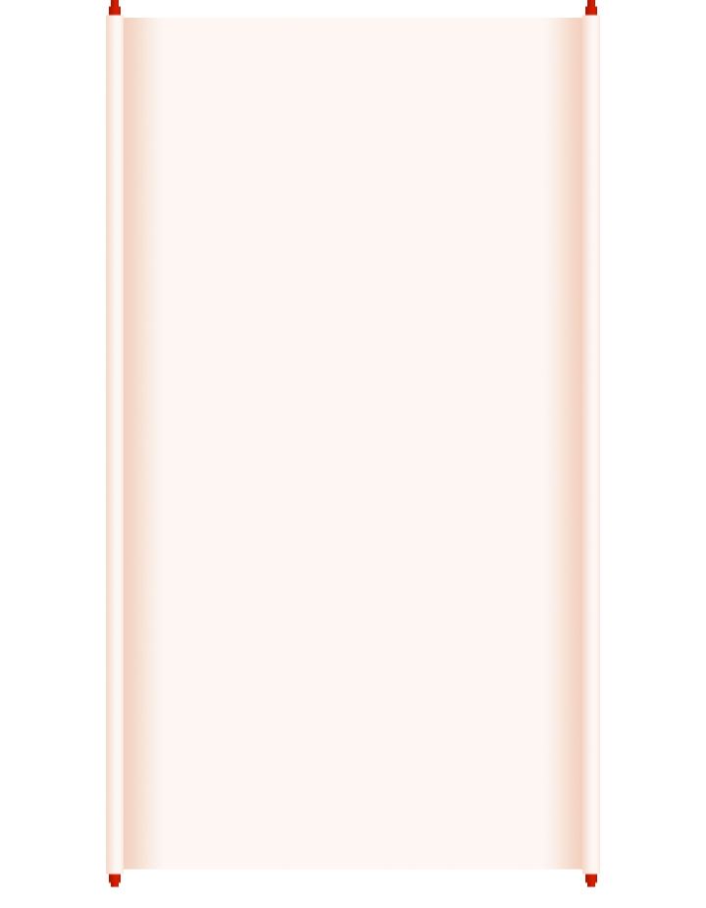
（ B ）2. What does the underlined (在...下面画线) part “shop assistant” mean in Chinese?
A. 经理 B. 售货员 C. 导游 D. 老师
（ C ）3. Put the sentences in the right order (顺序).
①choosing the color of clothes；
②choosing the style of clothes；
③getting a good price；
④finding the right size；
A. ①②④③ B. ④③①② C. ②①④③ D. ④③②①
（ D ）4. What’s the best title (标题) for the passage?
A. The clothes and styles B. The clothes and colors
C. The clothes and prices D. Ideas of buying clothes
七年级英语上册 | 阅读理解期末专练
【二】
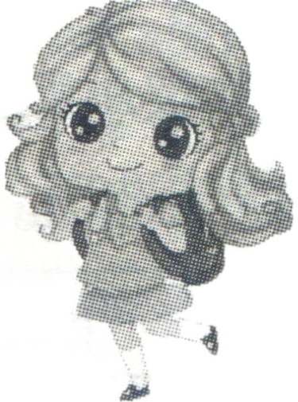 | This is Alice.  What is in Alice's schoolbag?  ★ A yellow pen  ★ A blue ruler  ★ A green cup  ★ An orange
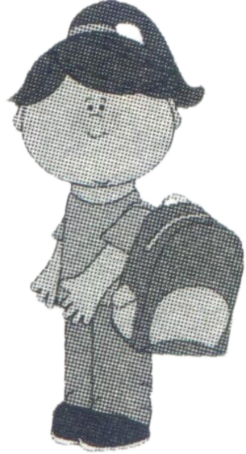 | This is Cindy.  What is in Cindy's schoolbag?  ★ A purple pen  ★ A red cup  ★ A key  ★ A CD
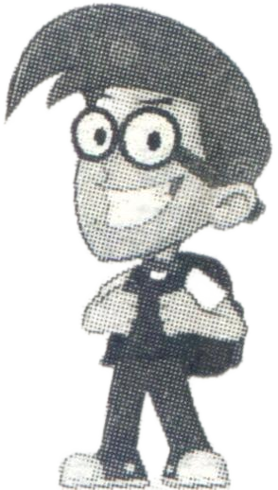 | This is Frank.  What is in Frank's schoolbag?  ★ A green jacket  ★ A black pen  ★ An English book  ★ A map
（ A ）1. Alice's pen is .
A. yellow B. blue C. red D. purple
（ D ）2. You can see a in Cindy's schoolbag.
A. ruler B. jacket C. map D. key
（ A ）3. has a map.
A. Frank B. Cindy C. Alice D. Eric
（ B ）4. Everyone(每个人) has a .
A. book B. pen C. CD D. cup
（ C ）5. are green.
A. Alice's cup and Frank's map B. Cindy's pen and Frank's jacket
C. Alice's cup and Frank's jacket D. Cindy's key and Alice's ruler
七年级英语上册 | 阅读理解期末专练
【三】
Mr Clark goes to a dinner party in old clothes. He comes into the room, but the people in the room don’t look at him. They don’t ask him to sit at the table.
Mr Clark goes home and puts on (穿上) his good clothes. He goes back to the party. People in the room stands up and smiles at him. They give him very good food to eat.
Mr Clark takes off his clothes, and puts them in the food and say, “Eat, clothes!”
The other people ask, “What are you doing?”
He answers, “I’m asking my coat (外套) to eat food. When I am wearing my old clothes, you don’t look at me. You don’t ask me to sit down. Now I am in these clothes. And you give me very good food. Now I know, you give the food to my clothes, not to me!”
（ B ）1. How does Mr Clark goes to the party at first?
A. With his friends. B. In old clothes.
C. With good food. D. In good clothes.
（ D ）2. When Mr Clark comes to the party in good clothes, people ______.
A. don’t know him B. don’t look at him
C. don’t ask him to sit at the table D. are good with him
（ A ）3. Mr Clark asks ______ to eat the food.
A. his coat B. his old clothes C. his parents D. the people
（ C ） 4. “Takes off” means (意思是) ______ in Chinese.
A. 买下 B. 收起 C. 脱下 D. 拿走
（ B ）5. From the story (故事), we know ______.
A. Mr Clark takes some good food to the party
B. Mr Clark does not like the people at the party
C. The people at the party don’t know Mr Clark
D. Mr Clark was not good with the people at the party
七年级英语上册 | 阅读理解期末专练
【一】
Do you often go shopping? You go to the clothes store and see a lot of clothes. Can you buy the right clothes for yourself? Here are some ideas for you.
First, ask yourself a question: What style (款式) of clothes do I want? In this way, you can know the style of clothes.
Then, choose the color. You can find some clothes in all colors. Some people like red and others like black.
Next, find the right size. If you are short, you can choose size S.
Finally, ask the shop assistant to give you a good price.
（ A ）1. If you are short, you can choose .
A. size S B. size M C. size L D. size XL
（ B ）2. What does the underlined (在...下面画线) part “shop assistant” mean in Chinese?
A. 经理 B. 售货员 C. 导游 D. 老师
（ C ）3. Put the sentences in the right order (顺序).
①choosing the color of clothes；
②choosing the style of clothes；
③getting a good price；
④finding the right size；
A. ①②④③ B. ④③①② C. ②①④③ D. ④③②①
（ D ）4. What’s the best title (标题) for the passage?
A. The clothes and styles B. The clothes and colors
C. The clothes and prices D. Ideas of buying clothes
七年级英语上册 | 阅读理解期末专练
【二】
This is Alice.
What is in Alice's schoolbag?
★ A yellow pen
★ A blue ruler
★ A green cup
★ An orange
This is Cindy.
What is in Cindy's schoolbag?
★ A purple pen
★ A red cup
★ A key
★ A CD
This is Frank.
What is in Frank's schoolbag?
★ A green jacket
★ A black pen
★ An English book
★ A map
（ A ）1. Alice's pen is .
A. yellow B. blue C. red D. purple
（ D ）2. You can see a in Cindy's schoolbag.
A. ruler B. jacket C. map D. key
（ A ）3. has a map.
A. Frank B. Cindy C. Alice D. Eric
（ B ）4. Everyone(每个人) has a .
A. book B. pen C. CD D. cup
（ C ）5. are green.
A. Alice's cup and Frank's map B. Cindy's pen and Frank's jacket
C. Alice's cup and Frank's jacket D. Cindy's key and Alice's ruler
七年级英语上册 | 阅读理解期末专练
【三】
Mr Clark goes to a dinner party in old clothes. He comes into the room, but the people in the room don’t look at him. They don’t ask him to sit at the table.
Mr Clark goes home and puts on (穿上) his good clothes. He goes back to the party. People in the room stands up and smiles at him. They give him very good food to eat.
Mr Clark takes off his clothes, and puts them in the food and say, “Eat, clothes!”
The other people ask, “What are you doing?”
He answers, “I’m asking my coat (外套) to eat food. When I am wearing my old clothes, you don’t look at me. You don’t ask me to sit down. Now I am in these clothes. And you give me very good food. Now I know, you give the food to my clothes, not to me!”
（ B ）1. How does Mr Clark goes to the party at first?
A. With his friends. B. In old clothes.
C. With good food. D. In good clothes.
（ D ）2. When Mr Clark comes to the party in good clothes, people ______.
A. don’t know him B. don’t look at him
C. don’t ask him to sit at the table D. are good with him
（ A ）3. Mr Clark asks ______ to eat the food.
A. his coat B. his old clothes C. his parents D. the people
（ C ） 4. “Takes off” means (意思是) ______ in Chinese.
A. 买下 B. 收起 C. 脱下 D. 拿走
（ B ）5. From the story (故事), we know ______.
A. Mr Clark takes some good food to the party
B. Mr Clark does not like the people at the party
C. The people at the party don’t know Mr Clark
D. Mr Clark was not good with the people at the party

