
2024年秋新人教版 | 七年级英语上册
完形填空期末复习专练
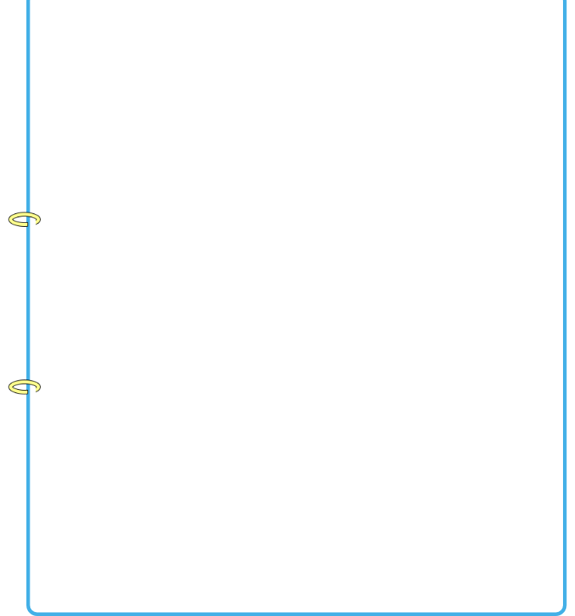
①
John is an English boy and he is a student in a middle school now. He likes doing sports. His favorite _________ is white. It is _________ today. He needn’t go to school. He wants to buy a jacket for school. John’s mother is _________ at work(工作), so he must go to the _________ store with his father. They buy a white _________ there. He likes it very much, _________ he wants to wear(穿) the jacket to school every day.
John has a good friend. _________ name is Alan. He goes to school with Alan every day. One day, the two _________ were going to school. Alan asked, “Where is your jacket, John?” “Oh, it is in my room. I don’t _________ to wear it.” said John. “_________ not, John?” asked Alan. “Your jacket looks very _________.” John answered, “A button(纽扣) _________ my jacket is lost. I can’t _________ the same button. So I don’t want to wear that jacket.”
“Why not change(更换) all the buttons on the jacket?” said Alan “That sounds _________,” said John. He did this and wore(穿) the _________ jacket again the next day.
（ B ）1.A．sport B．color C．subject D．music
（ D ）2.A．Wednesday B．Thursday C．Friday D．Saturday
（ B ）3.A．late B．busy C．free D．useful
（ A ）4.A．clothes B．fruit C．vegetable D．book
（ C ）5.A．skirt B．T-shirt C．jacket D．sweater
（ A ）6.A．so B．but C．or D．because
（ C ）7.A．Your B．Her C．His D．My
（ C ）8.A．cousins B．uncles C．friends D．brothers
（ D ）9.A．ask B．call C．think D．want
（ A ）10.A．Why B．Who C．Where D．When
（ B ）11.A．big B．nice C．small D．long
（ D ）12.A．in B．about C．for D．on
（ C ）13.A．sell B．say C．find D．need
（ A ）14.A．great B．boring C．difficult D．relaxing
（ A ）15.A．white B．yellow C．green D．brown
2024年秋新人教版 | 七年级英语上册
完形填空期末复习专练
②
Look at the photo. It’s my family. The old man and the old _________ are my grandparents. This is my father. He is next to his brother, my _________. This woman is my mother. She is my English teacher. You can _________ three kids in the photo. The two girls are my _________. The girl in a red dress（裙子）is Nancy, _________ the girl in a yellow dress is Susan. Who is the boy, do you know? It’s me. My grandparents live in the USA. I live in Beijing _________ my parents now. My father is a _________. He works in Beijing Hospital（医院）. He often has milk _________ breakfast. And he likes to eat _________. My mother often _________ some eggs and some milk.
Today is my birthday. In the morning, my grandparents _________ a big birthday cake. My father buys a nice watch _________ me. My sisters go to buy some drinks and food. They want to have a birthday party for me. _________ about 6:00 p.m., all my friends come. They _________ the birthday song. I am so surprised. I _________ all my friends and family. How happy I am!
（ C ）1.A．boy B．girl C．woman
（ B ）2.A．aunt B．uncle C．sister
（ A ）3.A．see B．take C．help4.
（ C ）4.A．sister B．girls C．sisters
（ A ）5.A．and B．but C．with
（ C ）6.A．from B．of C．with
（ B ）7.A．teacher B．doctor C．farmer
（ A ）8.A．for B．to C．in
（ B ）9.A．a bread B．some bread C．many bread
（ B ）10.A．eat B．has C．have
（ A ）11.A．make B．makes C．do
（ C ）12.A．on B．gives C．for
（ C ）13.A．In B．On C．At
（ B ）14.A．sings B．sing C．singing
（ C ）15.A．play B．gives C．thank
2024年秋新人教版 | 七年级英语上册
完形填空期末复习专练
③
Today is Friday. It’s my favorite ______. Do you know ______? Because I have science and history ______ Friday morning. I like ______ very much. And there are other ______ today. At 8 o’clock I have ______. Then I have ______. It’s really fun. Mrs. Jones is my science teacher. She is also my ______ teacher. Then ______ ten to ten forty I have history. It’s very ______. I like it. Next, I have math. It’s at eleven and it is the ______ class in the morning. Math is difficult, so I ______ like it. But I know I must study hard at it ______ it is useful.Lunch is ______ twelve o’clock. I often ______ hamburgers, eggs and a cup of orange.
Friday morning
Time | Subject
8: 00—8: 40 | Chinese
9: 00—9: 40 | science
10: 00—10: 40 | history
11: 00—11: 40 | math
12: 00 | lunch-time
（ B ）1.A．month B．day C．week D．year
（ C ）2.A．how B．what C．why D．where
（ A ）3.A．on B．in C．at D．about
（ D ）4.A．they B．they’re C．theirs D．them
（ D ）5.A．schools B．stores C．sports D．subjects
（ C ）6.A．science B．English C．Chinese D．history
（ A ）7.A．science B．math C．history D．art
（ B ）8.A．interesting B．favorite C．relaxing D．happy
（ A ）9.A．from B．at C．on D．in
（ D ）10.A．same B．difficult C．boring D．interesting
（ C ）11.A．first B．second C．last D．easy
（ A ）12.A．don’t B．doesn’t C．am not D．isn’t
（ B ）13.A．but B．because C．so D．do
（ B ）14.A．on B．at C．in D．as
（ D ）15.A．eats B．eat C．has D．have
2024年秋新人教版 | 七年级英语上册
完形填空期末复习专练
④
Alice and Grace are twin （双胞胎） sisters. Their birthday is on September 20th ________ it is coming soon. Alice and Grace are talking about it now.
Alice says, “Every year we have a birthday party and ________ a birthday cake. It’s always the same. Sounds ________, doesn’t it? This year I ________ a different （不同的） one.”
“What do you want to do on that day?” Grace ________.
“Do you know our classmate, David? His mother is not ________. She must see a doctor, but she doesn’t have much ________. So I want to help ________. What do you think of it, Grace?”
“Great!” says Grace. “I think a flea market （跳蚤市场） is ________. We can sell many ________ there-model planes, clothes and books.”
“Yes, you’re ________. People can ________ those things and we can get some money and help David’s mother. Let’s do it.” says Alice.
Later, their ________ know about this, and they want to help David’s mother, too. Alice’s family are very nice and ________. They all think that everyone should give a hand to people ________.
（ B ）1.A．but B．and C．or D．because
（ C ）2.A．find B．take C．eat D．like
（ A ）3.A．boring B．interesting C．great D．good
（ D ）4.A．welcome B．know C．get D．want
（ A ）5.A．asks B．answers C．thinks D．calls
（ B ）6.A．nice B．healthy C．careful D．busy
（ C ）7.A．fun B．food C．money D．time
（ C ）8.A．him B．me C．her D．us
（ D ）9.A．bad B．relaxing C．difficult D．good
（ B ）10.A．bags B．things C．boxes D．maps
（ C ）11.A．late B．good C．right D．happy
（ A ）12.A．buy B．see C．play D．love
（ D ）13.A．friends B．sons C．teachers D．parents
（ A ）14.A．kind B．tidy C．well D．lovely15.
（ B ）15.A．in pairs B．in need C．on TV D．in bed
2024年秋新人教版 | 七年级英语上册
完形填空期末复习专练
①
John is an English boy and he is a student in a middle school now. He likes doing sports. His favorite _________ is white. It is _________ today. He needn’t go to school. He wants to buy a jacket for school. John’s mother is _________ at work(工作), so he must go to the _________ store with his father. They buy a white _________ there. He likes it very much, _________ he wants to wear(穿) the jacket to school every day.
John has a good friend. _________ name is Alan. He goes to school with Alan every day. One day, the two _________ were going to school. Alan asked, “Where is your jacket, John?” “Oh, it is in my room. I don’t _________ to wear it.” said John. “_________ not, John?” asked Alan. “Your jacket looks very _________.” John answered, “A button(纽扣) _________ my jacket is lost. I can’t _________ the same button. So I don’t want to wear that jacket.”
“Why not change(更换) all the buttons on the jacket?” said Alan “That sounds _________,” said John. He did this and wore(穿) the _________ jacket again the next day.
（ B ）1.A．sport B．color C．subject D．music
（ D ）2.A．Wednesday B．Thursday C．Friday D．Saturday
（ B ）3.A．late B．busy C．free D．useful
（ A ）4.A．clothes B．fruit C．vegetable D．book
（ C ）5.A．skirt B．T-shirt C．jacket D．sweater
（ A ）6.A．so B．but C．or D．because
（ C ）7.A．Your B．Her C．His D．My
（ C ）8.A．cousins B．uncles C．friends D．brothers
（ D ）9.A．ask B．call C．think D．want
（ A ）10.A．Why B．Who C．Where D．When
（ B ）11.A．big B．nice C．small D．long
（ D ）12.A．in B．about C．for D．on
（ C ）13.A．sell B．say C．find D．need
（ A ）14.A．great B．boring C．difficult D．relaxing
（ A ）15.A．white B．yellow C．green D．brown
2024年秋新人教版 | 七年级英语上册
完形填空期末复习专练
②
Look at the photo. It’s my family. The old man and the old _________ are my grandparents. This is my father. He is next to his brother, my _________. This woman is my mother. She is my English teacher. You can _________ three kids in the photo. The two girls are my _________. The girl in a red dress（裙子）is Nancy, _________ the girl in a yellow dress is Susan. Who is the boy, do you know? It’s me. My grandparents live in the USA. I live in Beijing _________ my parents now. My father is a _________. He works in Beijing Hospital（医院）. He often has milk _________ breakfast. And he likes to eat _________. My mother often _________ some eggs and some milk.
Today is my birthday. In the morning, my grandparents _________ a big birthday cake. My father buys a nice watch _________ me. My sisters go to buy some drinks and food. They want to have a birthday party for me. _________ about 6:00 p.m., all my friends come. They _________ the birthday song. I am so surprised. I _________ all my friends and family. How happy I am!
（ C ）1.A．boy B．girl C．woman
（ B ）2.A．aunt B．uncle C．sister
（ A ）3.A．see B．take C．help4.
（ C ）4.A．sister B．girls C．sisters
（ A ）5.A．and B．but C．with
（ C ）6.A．from B．of C．with
（ B ）7.A．teacher B．doctor C．farmer
（ A ）8.A．for B．to C．in
（ B ）9.A．a bread B．some bread C．many bread
（ B ）10.A．eat B．has C．have
（ A ）11.A．make B．makes C．do
（ C ）12.A．on B．gives C．for
（ C ）13.A．In B．On C．At
（ B ）14.A．sings B．sing C．singing
（ C ）15.A．play B．gives C．thank
2024年秋新人教版 | 七年级英语上册
完形填空期末复习专练
③
Today is Friday. It’s my favorite ______. Do you know ______? Because I have science and history ______ Friday morning. I like ______ very much. And there are other ______ today. At 8 o’clock I have ______. Then I have ______. It’s really fun. Mrs. Jones is my science teacher. She is also my ______ teacher. Then ______ ten to ten forty I have history. It’s very ______. I like it. Next, I have math. It’s at eleven and it is the ______ class in the morning. Math is difficult, so I ______ like it. But I know I must study hard at it ______ it is useful.Lunch is ______ twelve o’clock. I often ______ hamburgers, eggs and a cup of orange.
Friday morning
Time | Subject
8: 00—8: 40 | Chinese
9: 00—9: 40 | science
10: 00—10: 40 | history
11: 00—11: 40 | math
12: 00 | lunch-time
（ B ）1.A．month B．day C．week D．year
（ C ）2.A．how B．what C．why D．where
（ A ）3.A．on B．in C．at D．about
（ D ）4.A．they B．they’re C．theirs D．them
（ D ）5.A．schools B．stores C．sports D．subjects
（ C ）6.A．science B．English C．Chinese D．history
（ A ）7.A．science B．math C．history D．art
（ B ）8.A．interesting B．favorite C．relaxing D．happy
（ A ）9.A．from B．at C．on D．in
（ D ）10.A．same B．difficult C．boring D．interesting
（ C ）11.A．first B．second C．last D．easy
（ A ）12.A．don’t B．doesn’t C．am not D．isn’t
（ B ）13.A．but B．because C．so D．do
（ B ）14.A．on B．at C．in D．as
（ D ）15.A．eats B．eat C．has D．have
2024年秋新人教版 | 七年级英语上册
完形填空期末复习专练
④
Alice and Grace are twin （双胞胎） sisters. Their birthday is on September 20th ________ it is coming soon. Alice and Grace are talking about it now.
Alice says, “Every year we have a birthday party and ________ a birthday cake. It’s always the same. Sounds ________, doesn’t it? This year I ________ a different （不同的） one.”
“What do you want to do on that day?” Grace ________.
“Do you know our classmate, David? His mother is not ________. She must see a doctor, but she doesn’t have much ________. So I want to help ________. What do you think of it, Grace?”
“Great!” says Grace. “I think a flea market （跳蚤市场） is ________. We can sell many ________ there-model planes, clothes and books.”
“Yes, you’re ________. People can ________ those things and we can get some money and help David’s mother. Let’s do it.” says Alice.
Later, their ________ know about this, and they want to help David’s mother, too. Alice’s family are very nice and ________. They all think that everyone should give a hand to people ________.
（ B ）1.A．but B．and C．or D．because
（ C ）2.A．find B．take C．eat D．like
（ A ）3.A．boring B．interesting C．great D．good
（ D ）4.A．welcome B．know C．get D．want
（ A ）5.A．asks B．answers C．thinks D．calls
（ B ）6.A．nice B．healthy C．careful D．busy
（ C ）7.A．fun B．food C．money D．time
（ C ）8.A．him B．me C．her D．us
（ D ）9.A．bad B．relaxing C．difficult D．good
（ B ）10.A．bags B．things C．boxes D．maps
（ C ）11.A．late B．good C．right D．happy
（ A ）12.A．buy B．see C．play D．love
（ D ）13.A．friends B．sons C．teachers D．parents
（ A ）14.A．kind B．tidy C．well D．lovely15.
（ B ）15.A．in pairs B．in need C．on TV D．in bed

