
七上英语期末专项复习——完形填空
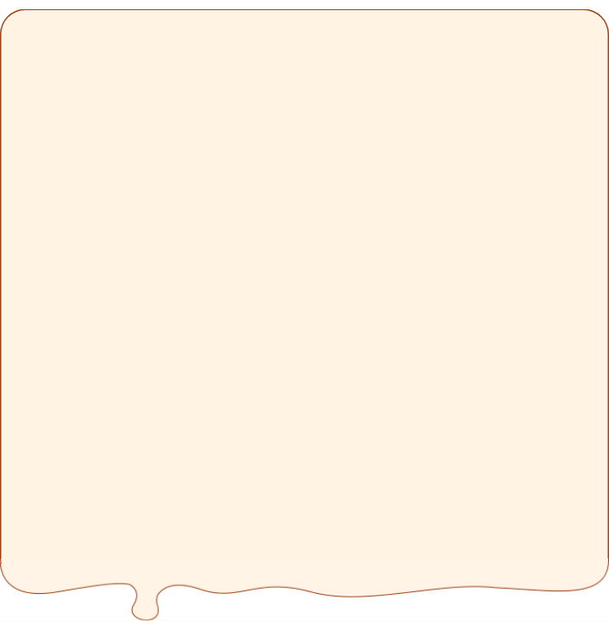
【一】
My friend Bill is 14. He ________ a very good family. His father works ________ a hospital (医院) in Beijing. So he has a healthy eating habit. He usually ________ two eggs and a glass of milk for breakfast and ________ goes to work by car. Bill’s mother is an English ________ in our school. She usually has some fruit and milk for breakfast. Her English is very good. We all love her and her ________ . Bill is my friend and he is ________ my classmate. He eats a hamburger and two bananas for breakfast. He likes ice-cream, too. ________ his mother doesn’t want him to eat it. She says it is not ________. And he can be very ________.
（ B ）1.A．have B．has C．is
（ A ）2.A．in B．on C．to
（ C ）3.A．makes (做) B．drinks C．has
（ B ）4.A．so B．then C．after
（ A ）5.A．teacher B．student C．worker
（ B ）6.A．plays B．classes C．videos
（ C ）7.A．too B．either C．also
（ A ）8.A．But B．And C．Then
（ B ）9.A．happy B．healthy C．easy
（ A ）10.A．fat B．boring C．fun
七上英语期末专项复习——完形填空
【二】
Hello, I am Jenny Smith. Jenny is my first name, and ________ is my last name. I am ________. I am ________ China now. I have some ________. They are Eric, Bob and Cindy. We ________ middle school students.
Look! This is ________ ID card. It is my card. You can see a ________ of me on it. I’m in a red jacket, because ________ is my favorite color. ________ phone number is 655-3244.
Eric likes model planes. You can always ________ a model plane in his schoolbag. Bob likes photos. Look here, ________ is a photo of his family. The girl in the photo is his ________, Linda, she is two.
Cindy is a nice girl, but she is not ________. Her things are everywhere. She always asks, “________ are my keys?” “My ruler?” “It’s not easy for her to ________ things.
（ C ）1.A．Jenny B．Jenny Smith C．Smith D．Eric
（ A ）2.A．twelve B．student C．friend D．teacher
（ B ）3.A．on B．in C．at D．about
（ D ）4.A．students B．brothers C．families D．friends
（ C ）5.A．am B．is C．are D．be
（ B ）6.A．a B．an C．the D．/
（ D ）7.A．book B．map C．ruler D．photo
（ C ）8.A．blue B．yellow C．red D．green
（ A ）9.A．My B．His C．Her D．Your
（ A ）10.A．see B．know C．spell D．meet
（ B ）11.A．That B．This C．They D．These
（ D ）12.A．brother B．mother C．grandmother D．sister
（ C ）13.A．great B．fine C．tidy D．good
（ B ）14.A．What B．Where C．Who D．How
（ A ）15.A．find B．lose C．say D．be
七上英语期末专项复习——完形填空
【三】
Sophia is thirteen years old and she is a very ________ girl. At school she likes all her ________ and ________ classmates all like her.
Sophia has a happy ________. Her parents are doctors and she ________ them very much. Now it is the second Sunday in May. It’s ________ Day. She ________ to do some things for her mother. She thinks over（仔细考虑）about it and has a good ________ . She cooks ________ for her mother at seven in the morning, then she cleans the living room. ________ that she goes to the store and ________ some flowers and a ________ hat for her mother. Purple is her mother’s favourite color. When her mother sees the flowers and hat, She feels very ________ . In the afternoon, they have a ________ with Sophia’s grandparents. They play games and watch TV together. ________ has a good time.
（ C ）1.A．bad B．big C．nice D．small
（ D ）2.A．parents B．brothers C．friends D．classmates
（ A ）3.A．her B．his C．my D．your
（ D ）4.A．map B．key C．room D．family
（ C ）5.A．sees B．tells C．loves D．thinks
（ B ）6.A．Father’s B．Mother’s C．Children’s D．School
（ C ）7.A．comes B．calls C．wants D．says
（ D ）8.A．job B．bag C．box D．idea
（ D ）9.A．tea B．dinner C．lunch D．breakfast
（ C ）10.A．But B．About C．After D．Because
（ A ）11.A．buys B．sells C．makes D．watches
（ D ）12.A．red B．pink C．blue D．purple
（ B ）13.A．relaxing B．happy C．boring D．interesting
（ A ）14.A．party B．trip C．class D．meeting
（ D ）15.A．Somebody B．Anybody C．Nobody D．Everybody
七上英语期末专项复习——完形填空
【四】
Hello, I’m Tina. This is my _______ Henry. I’m his sister. We love _______, and we often go to the school sports club (俱乐部). We _______ sports are good for _______ health and it is also a good way to make friends. I like _______ and I play it _______ the club three times a week. I _______ two tennis rackets (网球拍) and some books _______ tennis. Henry doesn’t like playing tennis. He thinks it’s _______. He likes playing basketball. He is good at (擅长) it and he is on the basketball team (队). ________ about you? Do you love sports?
（ A ）1.A．brother B．cousin C．father D．friend
（ A ）2.A．sports B．school C．family D．classes
（ C ）3.A．see B．ask C．think D．thank
（ D ）4.A．his B．my C．their D．our
（ C ）5.A．baseball B．basketball C．tennis D．soccer
（ A ）6.A．in B．for C．with D．from
（ D ）7.A．likes B．like C．has D．have
（ D ）8.A．in B．for C．under D．about
（ B ）9.A．nice B．difficult C．welcome D．interesting
（ C ）10.What’s B．Where’s C．What D．Where
七上英语期末专项复习——完形填空
【一】
My friend Bill is 14. He ________ a very good family. His father works ________ a hospital (医院) in Beijing. So he has a healthy eating habit. He usually ________ two eggs and a glass of milk for breakfast and ________ goes to work by car. Bill’s mother is an English ________ in our school. She usually has some fruit and milk for breakfast. Her English is very good. We all love her and her ________ . Bill is my friend and he is ________ my classmate. He eats a hamburger and two bananas for breakfast. He likes ice-cream, too. ________ his mother doesn’t want him to eat it. She says it is not ________. And he can be very ________.
（ B ）1.A．have B．has C．is
（ A ）2.A．in B．on C．to
（ C ）3.A．makes (做) B．drinks C．has
（ B ）4.A．so B．then C．after
（ A ）5.A．teacher B．student C．worker
（ B ）6.A．plays B．classes C．videos
（ C ）7.A．too B．either C．also
（ A ）8.A．But B．And C．Then
（ B ）9.A．happy B．healthy C．easy
（ A ）10.A．fat B．boring C．fun
七上英语期末专项复习——完形填空
【二】
Hello, I am Jenny Smith. Jenny is my first name, and ________ is my last name. I am ________. I am ________ China now. I have some ________. They are Eric, Bob and Cindy. We ________ middle school students.
Look! This is ________ ID card. It is my card. You can see a ________ of me on it. I’m in a red jacket, because ________ is my favorite color. ________ phone number is 655-3244.
Eric likes model planes. You can always ________ a model plane in his schoolbag. Bob likes photos. Look here, ________ is a photo of his family. The girl in the photo is his ________, Linda, she is two.
Cindy is a nice girl, but she is not ________. Her things are everywhere. She always asks, “________ are my keys?” “My ruler?” “It’s not easy for her to ________ things.
（ C ）1.A．Jenny B．Jenny Smith C．Smith D．Eric
（ A ）2.A．twelve B．student C．friend D．teacher
（ B ）3.A．on B．in C．at D．about
（ D ）4.A．students B．brothers C．families D．friends
（ C ）5.A．am B．is C．are D．be
（ B ）6.A．a B．an C．the D．/
（ D ）7.A．book B．map C．ruler D．photo
（ C ）8.A．blue B．yellow C．red D．green
（ A ）9.A．My B．His C．Her D．Your
（ A ）10.A．see B．know C．spell D．meet
（ B ）11.A．That B．This C．They D．These
（ D ）12.A．brother B．mother C．grandmother D．sister
（ C ）13.A．great B．fine C．tidy D．good
（ B ）14.A．What B．Where C．Who D．How
（ A ）15.A．find B．lose C．say D．be
七上英语期末专项复习——完形填空
【三】
Sophia is thirteen years old and she is a very ________ girl. At school she likes all her ________ and ________ classmates all like her.
Sophia has a happy ________. Her parents are doctors and she ________ them very much. Now it is the second Sunday in May. It’s ________ Day. She ________ to do some things for her mother. She thinks over（仔细考虑）about it and has a good ________ . She cooks ________ for her mother at seven in the morning, then she cleans the living room. ________ that she goes to the store and ________ some flowers and a ________ hat for her mother. Purple is her mother’s favourite color. When her mother sees the flowers and hat, She feels very ________ . In the afternoon, they have a ________ with Sophia’s grandparents. They play games and watch TV together. ________ has a good time.
（ C ）1.A．bad B．big C．nice D．small
（ D ）2.A．parents B．brothers C．friends D．classmates
（ A ）3.A．her B．his C．my D．your
（ D ）4.A．map B．key C．room D．family
（ C ）5.A．sees B．tells C．loves D．thinks
（ B ）6.A．Father’s B．Mother’s C．Children’s D．School
（ C ）7.A．comes B．calls C．wants D．says
（ D ）8.A．job B．bag C．box D．idea
（ D ）9.A．tea B．dinner C．lunch D．breakfast
（ C ）10.A．But B．About C．After D．Because
（ A ）11.A．buys B．sells C．makes D．watches
（ D ）12.A．red B．pink C．blue D．purple
（ B ）13.A．relaxing B．happy C．boring D．interesting
（ A ）14.A．party B．trip C．class D．meeting
（ D ）15.A．Somebody B．Anybody C．Nobody D．Everybody
七上英语期末专项复习——完形填空
【四】
Hello, I’m Tina. This is my _______ Henry. I’m his sister. We love _______, and we often go to the school sports club (俱乐部). We _______ sports are good for _______ health and it is also a good way to make friends. I like _______ and I play it _______ the club three times a week. I _______ two tennis rackets (网球拍) and some books _______ tennis. Henry doesn’t like playing tennis. He thinks it’s _______. He likes playing basketball. He is good at (擅长) it and he is on the basketball team (队). ________ about you? Do you love sports?
（ A ）1.A．brother B．cousin C．father D．friend
（ A ）2.A．sports B．school C．family D．classes
（ C ）3.A．see B．ask C．think D．thank
（ D ）4.A．his B．my C．their D．our
（ C ）5.A．baseball B．basketball C．tennis D．soccer
（ A ）6.A．in B．for C．with D．from
（ D ）7.A．likes B．like C．has D．have
（ D ）8.A．in B．for C．under D．about
（ B ）9.A．nice B．difficult C．welcome D．interesting
（ C ）10.What’s B．Where’s C．What D．Where

