八年级英语上册 | 期末押题作文
【书面表达】常考主题范文7篇
【一】
假如你是一所国际学校的学生，你校广播站要招聘英语主持人，你想加入。请根据以下图示用英语做自我介绍，可适当发挥。
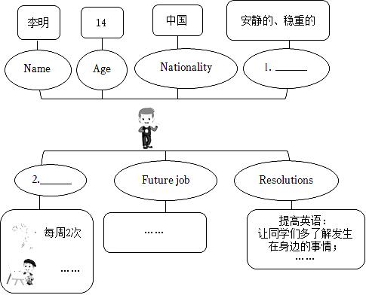

注意：
1. 请先在答题卡上填写图示中空格(一空一词)；
2. 须全面反映图文信息；
3. 文中不能出现真实姓名及学校名称；
4. 词数：80—100，开头已给出，且不计入总词数。
Hello, everyone! I am very glad to tell all of you about myself. My name is Li Ming. 1 am 14 years old. i come from China. 1 amvery calm and quiet. 1 like reading alone at home. 1 like playing basketbal. 1 go to the gym with my friends to play basketball twice aweek. My favorite job is to be a pilot because l like flying. I hope that through my broadcast, students can improve their English and leammore about what is happening around us. At the same time, the most important thing is to make them fall in love with English
【二】
假如你是学校英语社团的主持人，准备在全校开展中学生“Dream Show”的演讲活动，请根据下面的提示写一篇短文，谈一谈举行此活动的目的，号召大家积极参加。
提示：
1. help students practice English (build confidence...)
2. show more ideas (on the future plan, hobbies...)
要求：
1. 短文必须包含所有提示内容，可适当发挥。
2. 文中不能涉及真实的人名和校名。
3. 词数：80个左右。开头已给出，不计入总词数。
Hello, everyone! We plan to have a Dream Show, Everyone has dreams. So what's your dream?
The activity will be held in our school hall next month. Through this activity, it can help you practice leaming English. Not only canit help us build our confidence, but also it can improve our pronunciation. At the same time, we can also show more ideas, such as oufuture plans, hobbies and so on.
I believe you will learn a lot from this activity. I'm looking forward to your participation.
【三】
疫情政策放开之后，每个人都是自己健康的第一责任人，提高自身身体免疫力是抵御病毒的关键。寒假即将到来，同学们打算如何做来提高自身免疫力呢？请根据以下的提示，写一篇英语短文，介绍自己寒假提高免疫力的做法。
提示：
(1) Improve my physical health ( exercise, eat healthily, sleep well,... )
(2) Keep happy and relaxed (have a good relationship, listen to music, watch movies,... )
要求：
1. 短文需包括提示所给的所有要点，可适当发挥。
2.文中不得出现真实的人名和校名。
3.80 词左右，开头已给出，不计入总词数；
The winter holiday is coming. We should improve our immunity (免疫力) to fight against COVID-19. Here are my plans.
First, I will improve my physical health. I will exercise for at least half an hour every day. I will eat healthily during the wintervacation. I will eat more firuit and vegetables. I will also sleep for at least eight hours every night. What's more, I will keep happy andrelaxed. 1 willisten to some relaxing music and watch movies when I feel tired. 1 will have a good relationship with my family and myfriends.
I am sure l will have a good winter vacation.
【四】
假如你是Lisa，请根据以下信息写一篇短文。
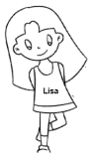 | 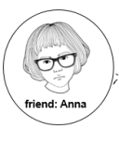 | 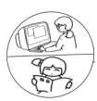 | 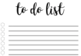
 | 1. Two differences (性格，外貌)  2. One thing in common (be good at tennis) | Free time Activities & Frequency (频率) | Winter vacation plan：  1. 认真完成作业；  2. 每天锻炼一个小时
注意：
1. 短文应包含图示所有信息；
2. 短文应适当使用比较级和最高级；
3. 短文应结构完整、语句通顺、句式多样；
4. 短文中不能出现个人和学校的真实信息；
5. 词数：80词左右。
My name's Lisa. l have a good fiend, Anna. She is quieter than me, and her hair is shorter than mine. However, we have some thingsin common. WVe are both good at tennis. 1 have a lot of hobbies. In my free time, 1 like reading and playing computer games. l read booksevery day because l can leam a lot from them, As for games, I only play it for relaxing. l usually play it two hours a week. Wintervacation is coming soon. To improve myself, I am going to finish my homework carefully and exercise for an hour every day.
【五】
2024年行至尾声，凡是过往皆为序章。面对即将到来的寒假，唯有不虚度，才能在新的一年里，距离自己的梦想近一点，再近一点。为了能度过一个充实且有意义的寒假，请你以“My Winter Holiday Plan”为题，结合下列要点写一写你的计划。
写作要点：
（1）制定新年计划，合理规划学习时间和所学科目；
（2）安排一些健康的休闲娱乐活动，和家人共度时光（如听音乐，运动等）；
（3）帮助父母做家务（至少包含两项劳动内容）。
写作要求：
（1）内容积极向上，并包含所给要点；
（2）文中不得透露个人信息，否则不予评分；
（3）词数80左右（短文开头和结尾已给出，不计入总词数）。
My Winter Holiday Plan
As the winter holiday is coming, it means a new start to me. I have a plan to make it meaningful and colorful.
First of al, the geography and biology exams in the coming year are important for me. To prepare for them, I decide to spend overtwo hours reading books about these two subjects every day, A fter study, I plan to go skating, because it's healthy for the mind and thebody, I also expect to help with housework, such as cleaning my room, doing the dishes, cooking and so on. I'd like to learn to make soupfor my family.
This plan will improve myself and help me get closer to my dreams.
Hope my dreams come true in the new year. The best is yet to come!
【六】
假定你是李明，你得知在英国的朋友Bob得甲流生病了，请你写一封电子邮件叮嘱他生病后的一些注意事项。
内容包括：
(1) 表达关心 (我很抱歉听说你生病了)；
(2) 描述你出现健康问题的一次经历；
(3) 对如何保持健康提出至少两点建议。
作文要求：
(1) 不能照抄原文，不得在文中出现学校真实的名称和学生的真实姓名。
(2) 语句连贯，词数80左右。作文开头和结尾已经给出，不计入总词数。
Dear Bob,
I’m sorry to hear that you have H1N1 flu. l also caught a cold last month. i had a high fever and coughed. i drank a lot of water andtook some medicine. 1 realized the importance of health. So it is necessary for us to know how to keep healthy.
First, it's necessary for us to keep a balanced diet. We should eat more vegetables and fruit which contain lots of vitamins and lessfat. We should also try to eat less meat. What's more, keeping a positive attitude to our life is good for our health. Last but not least, takeproper exercise every day.
I hope you will get better soon. Best wishes!
Yours,
Li Ming
【七】
假如你是李华，你得知你的笔友Jim的家乡刚刚发生一场地震。这场地震不仅造成了很大的损失，也给当地人留下了心理阴影。请你根据以下提示内容，写一封信安慰他。
提示内容：
(1) 不要独处，要将自己的感受说出来，与别人分享。
(2) 多和家人朋友同学联系，与他们多沟通。
(3) 如果太过紧张焦虑，可求助于医生。
要求：
(1) 语句通顺、意思连贯、语法正确。
(2) 包含所有提示要点，可适当发挥。
(3) 80词左右 (信的格式及结尾已给出，不计入总词数)。
Dear Tom,
I have received your letter. I'm sorry to hear about the earthquake in your hometown. 1 understand how dificult and stressful it mustbe for you and your family. I'd like to offer some advice to help you cope.
Firstly, try not to be alone. Share your feelings with your family, friends, or classmates. Secondly, communication with loved ones isvery important, so keep in touch with them ofen. Lastly, if you feel too anxious or stressed, don't hesitate to seek help from a doctor.Remember, you are not alone, and things will get better.
Yours,
Li Hua

