
七上英语期末专项复习-------完形填空
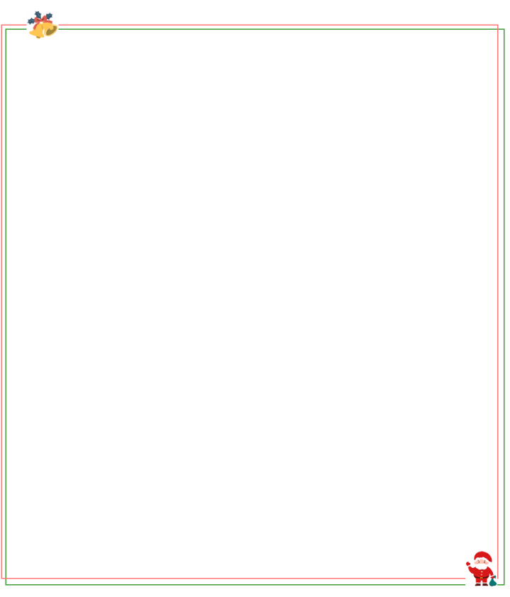
【一】
My name is Sam. My birthday is on______ . That’s National Day . I like music very much and I _______ like sports.
My birthday is coming. My mother _________ buy a beautiful shirt for me. On Sunday, she_________ me to a big _________store. There are ________ shirts and they are__________ blue, yellow and red. She selects a blue one. It looks cool.
My father gives me some CDs and a___________. He knows what I like. He wishes me to play sports more. I am very happy.
My parents want to have a_________ for me at home this year. My friends will come to it. We can play together. It’s very exciting _________my friends in my house.
（ D ）1.A．June 1st B．July 1st C．August 1st D．October 1st
（ B ）2.A．too B．also C．only D．don’t
（ D ）3.A．want B．wants C．need to D．wants to
（ B ）4.A．sells B．takes C．buys D．brings
（ B ）5.A．food B．clothes C．fruit D．book
（ D ）6.A．much B．a little C．lot of D．many
（ A ）7.A．in B．on C．to D．at
（ C ）8.A．pen B．storybook C．basketball D．hamburger
（ B ）9.A．school day B．birthday party C．sports game D．speech contest
（ A ）10.A．to play with B．to look for C．to learn about D．to listen to
七上英语期末专项复习-------完形填空
【二】
There is a saying , “ The early bird catches the worm (虫子) .” I always do things in time and work hard .
I get up early every _______ . I have breakfast quickly and then go to school . _______ school , I go home and do my homework as soon as possible . I don’t watch TV _______ play computer games before I finish my homework . If there are some difficult problems , I will ask my parents to teach _______ . I have time to play and do something _______ after doing my homework . One of my interests is acting . I have acting lessons _______ Saturday afternoons . I want to be a good _______ some day . I also like _______ sports . I can play basketball and I am in the school _______ club .
It’s a little difficult to have a good habit (习惯) . Luckily , my teachers and parents often ________ me with my school work and hobbies . I think I can do it well .
（ A ）1.A．morning B．afternoon C．evening D．night
（ C ）2.A．When B．Before C．After D．Then
（ B ）3.A．and B．or C．but D．also
（ D ）4.A．them B．him C．you D．me
（ B ）5.A．boring B．interesting C．scary D．sad
（ D ）6.A．at B．of C．in D．on
（ C ）7.A．teacher B．worker C．actor D．musician
（ C ）8.A．working B．leaving C．doing D．going
（ A ）9.A．basketball B．baseball C．football D．volleyball
（ B ）10.A．need B．help C．ask D．take
七上英语期末专项复习-------完形填空
【三】
Briar and Bramble are two brown bear brothers . They live happily in a forest . However , their peaceful life is disturbed (被扰乱) _______ Logger Vick . Vick comes from the big city and he is a bad man . He wants to cut down the _______ in the forest .
Of course the bear brothers will not let Vick’s plan _______ . They fight against the _______ man . Because Briar is smart (聪明的) , he can think out a lot of _______ . For example , they steal (偷) Vick’s tools from _______ and make their own tools . Bramble is not as smart as Briar , _______ he is very strong . Vick is a bit afraid of him . What’s more , the bear brothers have other animals to _______ them . Every time Vick _______ to cut down trees , he fails (失败).
Now you must know ________ I’m talking about . Yes , you’re right . It’s Boonie Bears . Do you love watching it ?
（ D ）1.A．with B．from C．without D．by
（ C ）2.A．bamboo B．flowers C．trees D．birds
（ A ）3.A．come true B．go out C．get fat D．get up
（ B ）4.A．good B．bad C．silly D．tired
（ D ）5.A．answers B．teams C．questions D．ways
（ A ）6.A．him B．them C．us D．her
（ C ）7.A．so B．and C．but D．because
（ B ）8.A．carry B．help C．find D．save
（ D ）9.A．hopes B．needs C．leaves D．tries
（ C ）10.A．why B．how C．what D．whose
七上英语期末专项复习-------完形填空
【四】
This is a photo ____ a classroom. It’s a big room. In the photo, you can see a table and thirty ____ .You can see a teacher and two students, _____.
Three ____ are on the table. A pencil case is on the desk. Two pens and two rulers are in____ pencil case. A backpack ____ behind a chair.
The teacher is Miss Yang____ is an English teacher. One student is Mike____ twelve years old. The other student is Simon. He is eleven____ in Class 2, Grade7. They are good friends. ____ math teacher is Mr. Hu. He is not here.
（ B ）1.A．for B．of C．to D．in
（ D ）2.A．desk and chair B．desks and chair
C．desk and chairs D．desks and chairs
（ A ）3.A．too B．please C．yes D．OK
（ C ）4.A．book B．the book C．books D．the books
（ A ）5.A．the B．a C．my D．\
（ C ）6.A．am B．are C．is D．does
（ D ）7.A．Her B．She’s C．Hers D．She
（ B ）8.A．He B．He’s C．His D．Him.
（ D ）9.A．He is B．She is C．They D．They’re
（ B ）10.A．Them B．Their C．Theirs D．They

