八年级英语上册 | 期末押题作文
【书面表达】热门主题范文6篇
【一】
假如你是Ben，平时学习刻苦，为了缓解压力，你决定过一个非常放松的周末。请以“My Weekend Plans”为题，根据下列表格内容写一篇文章，介绍你的周末计划。
提示词：relaxing 放松的
When |  | activities
Saturday | morning | go bike riding
Saturday | afternoon | go fishing
Saturday | evening | go to the movies
Sunday | the whole day | go to the countryside
Sunday | evening | read books
要求：
1．根据所给题目写一篇文章，词数不少于70个；
2．语言流畅，书写规范、卷面整洁；文中不得使用你的真实姓名、校名，否则以零分记；
3．书面表达必须写在答题卡上。
My Weekend Plans
I'm Ben， 1 study hard and I'm stressed out. So I plan to have a very relaxing weekend.
On Saturday morning， I'm going bike riding with my best friend. In the afternoon， I'm going fishing with my father. I enjoy fishingvery much. And in the evening， I'm going to the movies with my family. WVe're going to watch a comedy. 1 think it's very interestingThen on Sunday， want to spend the whole day in the beautiful countryside. 1 love nature. Maybe it can help me forget all my problems!And on Sunday evening， I'm going to read books， because I like books very much.
A great weekend! l can't wait!
【二】
我和Kelly（女名）是好朋友，放学后两人都喜欢看电视，但是我们喜欢不同的节目。请根据下表中的信息，写一写我和Kelly对电视节目的喜好以及对各节目的不同看法。
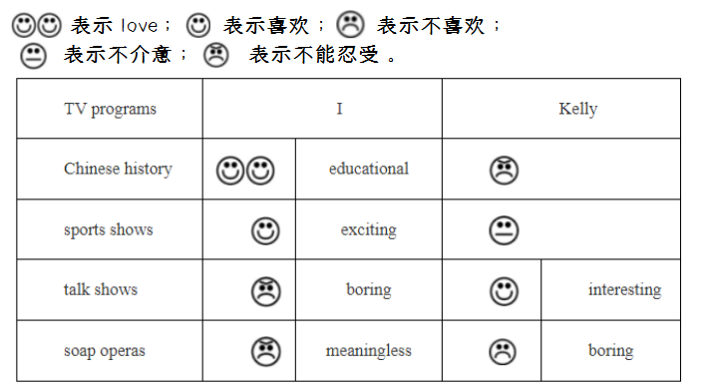
写作提示：

写作要求：
1. 内容需包含以上表格中所有信息，再添加一到两句开头语作为文章的衔接语；在部分节目后面给有形容词的请写出喜欢、不喜欢等的理由；可适当增加细节，使内容充实，行文连贯；
2. 语法正确、语言精练、表达准确，条理清晰；单词书写规范、字迹工整，卷面整洁；
3. 词数80左右。（开头首句已给出，不计入总词数。）
4. 不得使用真实姓名和学校名；
Kelly and I are good friends.We both like watching TV after school. But we like difierent programs. 1 love Chinese history. 1 thinkit's educational. But Kelly can't stand it， I like sports shows， because I think they are exciting， But Kelly doesn't mind them. can't standtalk shows， because l think they're boring. But Kelly likes talk shows， because she thinks they're interesting. l can't stand soap operas. lthink they're meaningless. Kelly can't stand them， either. She thinks they're boring.
【三】
假设你叫Tom，你的好友Lisa邀请你本周末去参加一次有关未来机器人的讨论，但你由于奶奶生病住院而无法前往。请给Lisa发一封电子邮件，告诉她你不能参加的原因(2-3个)，并谈谈你对未来机器人的预测
参考词汇：take part in(参加)，be ill in hospital(住院)
要求：
（1）文中不能出现真实姓名、学校、班级等信息。
（2）字数：80词左右。
Dear Lisa.
I am glad to receive your invitation to take part in the discussion about the robots at your home. However， l am sorry to tell you that ican't go there. My grandma is ill in hospital and my parents are not at home， so i have to take care of her. l predict there will be morerobots in the future. We will need robots to do more housework at home. I wish you will have a good time.
Yours
Tom
【四】
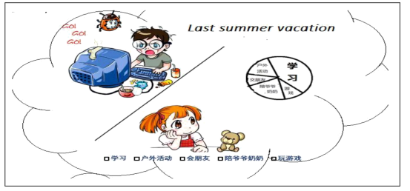
以下图画描述的是小明和小红去年的暑假生活。请用英语写一篇约100词的短文。

要求：
1. 完整叙述图画内容。
2. 结合自己的实际陈述个人观点。
The winter holiday is coming.But last year，Xiao ming and Xiao hong had different life on the summer holiday.
Xiao hong went to Beijing for her holiday，she went to the Summer Palace，climbed the Great Wall and went to many places ofinterest.When she was at home，she did her homework in the morning.In the aftemoon she played computer games.In the evening shewatched TV after a long walk with her grandparents.Sometimes she went to a movie with her friends.
Xiao hong had a colorful summer holiday，but Xiao ming didn’t.He played computer games all day.He didn't do anything else.
Well，What are they going to do on the winter holiday?
【五】
寒假就要到了，你想使你的寒假生活更加丰富多彩吗?
你是否应该：多多锻炼，保持健康；好好学习，完成好作业；回家多和家人交流；空余时间打算学点什么；你还有些什么愿望呢?(写1-2条)
请根据以上提示，以 My Resolutions for the Winter Vacation为题写一篇文章
要求：
1.字迹工整；
2.字数不少于80字，开头已给出，不计入总词数。
My Resolutions for the Winter Vacation
The winter vacation is coming. l am very excited. l want to have a rich and colorful vacation. Here are my resolutions for the wintervacation.
First, I will study hard and do my homework on time. Then I will do some exercise to keep healthy. In the afternoon, i will playbasketball with my friends. If'i have free time, I will help my mom do some housework. Also, I will spend some time communicatingwith my parents. In my spare time, I want to learn how to play the guitar. Besides, I want to go to the beach with my parents.
I hope I can have a happy vacation.
【六】
雨雪天气，事故多发。请根据以下要点给你校的英国交换生们写一份有关“冬季平安出行”的倡议书。
出行方式 | 注意事项
步行 | 谨慎慢行，以防止摔倒
骑车 | 不听音乐，不并排骑车
公交或地铁 | 排队候车，上车不推搡
注意：
1. 词数70左右；
2. 请结合实际，增加细节，适当发挥；
3. 文章的开头和结尾已为你写好，不计入总词数。
It’s much more common to see accidents on rainy or snowy days in winter. So it’s important for us to pay attention when going out.
When you travel on foot, you'd better walk slowly when there is ice on the ground. Ifnot, you may be easy to fall over. When ridinga bike. you shouldn't listen to music or go side by side with others. It's very dangerous. lf you choose to go out by bus or underground.you must stand in line and wait your turn to get on. Please don't push your way onto the bus or underground.
Anyway, safety comes first, Hope you can travel safely all the time.

