九年级英语上册 | 期末押题作文
【书面表达】热门主题范文6篇
【一】
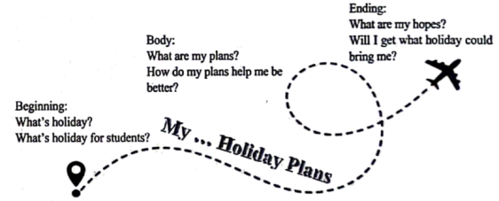
假期对学生来说是一段放松自己、关心家人、充实自我的时间。对于即将到来的暑假你有什么计划和安排？根据以下思维导图提示，以“My ________ Holiday Plans”为题，用英语写一篇80词左右的假期计划。

要求：
1.先补全题目，并将题目抄写在答题卡书面表达作答区域；
2.内容包括提示中所有的写作要点；
3.条理清楚，行文连贯，可适当发挥；
4.文中不能出现真实的人名、学校等信息；
My Wonderful Holiday Plans
A holiday is a special time for students to take a break from school and relax, It's a chance to enjoy some free time after workinghard in classes.
During my holiday, I plan to spend wonderful time with my family by having picnics in the park, playing board games together, andcooking meals with my parents. I also want to show my care for my parents by helping with household chores, such as washing dishes oltidying up the house. Additionally, I want to do much reading. Reading makes a full man. Besides, travelling is another good choice forsuch a long holiday, IfI have time, I also want to volunteer in our neighborhood.
I look forward to creating lasting memories with my family, reading more, learing new things, and showing more love to the worldduring this holiday. By completing these plans with joy, I'm sure !’ll retum feeling happy, connected, and ready for new experiences.
【二】
假如你是李华，你的美国笔友吉姆对中国传统文化很感兴趣。请你用英文介绍一下中国的传统节日——春节的情况。
思路点拨：
1.总体概述：春节是一个传统节日及其时间；
2.简要介绍人们在春节到来前的活动；
3.主要介绍人们在春节期间的活动。
要求：
1. 以The Spring Festival为题，写一篇短文，词数不少于60个；
2. 语言流畅、书写规范、卷面整洁。文中不得使用你的真实姓名、校名，否则以零分计；
3. 书面表达必须写在答题卡上，如在本卷上作答，一律不得分。
The Spring Festival
The Spring Festival is the most important traditional festival in China, which comes in January or February.
Before the Spring Festival, people buy new clothes and clean their houses. People who live or work away from their hometowns willgo back.
On New Year's Eve, all the family members get together to enjoy a big dinner and watch Spring Festival Gala. People also let ofifireworks. The elderly give red packets to children. During the Spring Festival, people visit their relaives and friends, and have mealswith them.
【三】
“双减”政策实施后，学生的课外活动更丰富了，一些有趣的学校社团也应运而生，如航模社团、轮滑社团、观鸟社团等。下周你们学校将开设一批新的社团，为了征集大家的建议，你校英文报组织了征文活动，请你根据以下要点提示，以“The club I’d like to start”为题，写一篇英语短文投稿。
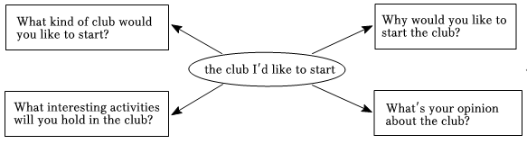

要求：
（1）文中须包含上图提示的所有信息，可适当发挥；
（2）文中不得出现考生的真实姓名和学校名称；
（3）词数100左右（开头已给出，不计入总词数）。
The club I’d like to start
In order to make our school life more colorful, all kinds of clubs have been started. In order to make our school life more colorful, all kinds of clubs have been stated, As for me. I'd like to start a cooking club. Themain reason is that cooking is an important life skill.
There can be some interesting activities in the club. First of all, the members can study recipes for different dishes together. By doingso, they can lear about all kinds of food. After that, they can watch some cooking videos which can be easily found online, and then theycan try cooking by themselves, In addition, the members can also take part in public services. For example, it's a good idea to go to theold people's home to cook for them.
I think the cooking club will be helpful for our growth. Besides, we can have fun as well as improve our life skills.
【四】
茫茫人海中，总有一些或熟悉或陌生的身影出现在你成长的时光故事里，为你指点迷津，助你健康成长。请以“The Person Who Helps Me Grow up”为题，用英语写一篇短文，记叙一位帮助你成长的人的故事，并谈谈你的感受。
要求：
1.语言流畅、书写规范、卷面整洁，词数不少于60个；
2.文中不得使用真实姓名、校名，否则以零分计；
3.书面表达必须写在答题卡上，如在本卷上作答，一律不得分。
The Person Who Helps Me Grow up
During the past three years, when l got into trouble, many people would like to gave me a hand. Linda is one of them. Let me tell yousomething about her.
WVhen I almost wanted to give up learning English, I met Linda, a girl from my study group. She told me that everyone meets troublesbut we should never give up easily. nstead, we should find out a suitable way and then work hard. Vith her help, l adjusted my attitudeand worded harder than before, Finally, i made great progress in English, Now, am an English lover and l won't give up anything easlyI am thankful to have a friend like Linda.
【五】
中华文化源远流长、博大精深，展现出了独特的魅力，让世界为之赞叹。假如你是李强，你的外国笔友Steven非常喜欢中国，想对中国文化有更进一步的了解。请你从以下几个方面，给他写一封email，向他简单介绍中国的文化特色。
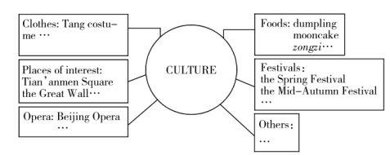

要求：
1.应包含思维导图提示中大部分要点，可适当进行拓展；
2.词数：80词左右；
3.书写工整规范；
4.书信首末已给出，不计入总词数，无需抄写在答题卡书面表达作答区域；
5.文中不得提及真实的人名、校名等相关信息。
Dear Steven,How is it going?
How is it going? 1 know you always want to know more about Chinese culture, I'm writing to tell you something about it
There're too many things we Chinese people are proud of. Chinese foods are famous all over the world. Special foods likedumplings, mooncakes and zongzi are not only delicious but also meaningful. They're closely connected with special festivals such as theSpring Festival, the Mid-Autumn Festival and the Dragon Boat Festival. As for traditional clothes, we have Tang costurmes. And there arelots of places of interest in China. lf you come to China, I suggest you visit Tian'anmen Square, the Great Wall and so on.
I'm looking forward to your email
Yours,
Li Qiang
【六】
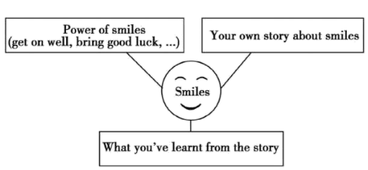
微笑是人类最美的语言。某英语报以“smiles”为题，举办中学生征文活动，请根据下面的图表信息，写一篇英语短文。内容包括：微笑的力量、你的微笑故事以及故事给予你的启示。

提示：
1.短文应包括图表中的全部信息，条理清楚，行文连贯。
2.短文中不能出现真实的人名与地名。
3.词数不少于80，开头已给出，不计入总词数。
Smiles
A smile is the most beautiful language of human beings.- A smile shows you are kind and friendly. it helps you get on well with others. ltalso brings good luck and makes others feel warm.
When I was in Grade6, a new student came to our class. He did badly in schoolwork. No one talked with him. He felt very lonely. Whenilearnt this, each time l met him, I gave him a big smile. Afterwards, he often asked me questions about study. We became good friendsand he did better and better in his study, He said it was my smile that made him more confident and outgoingSmiles are so important to our life, so let's try to smile more. If we smile to life, life will smile back to us.Possible Version Two

