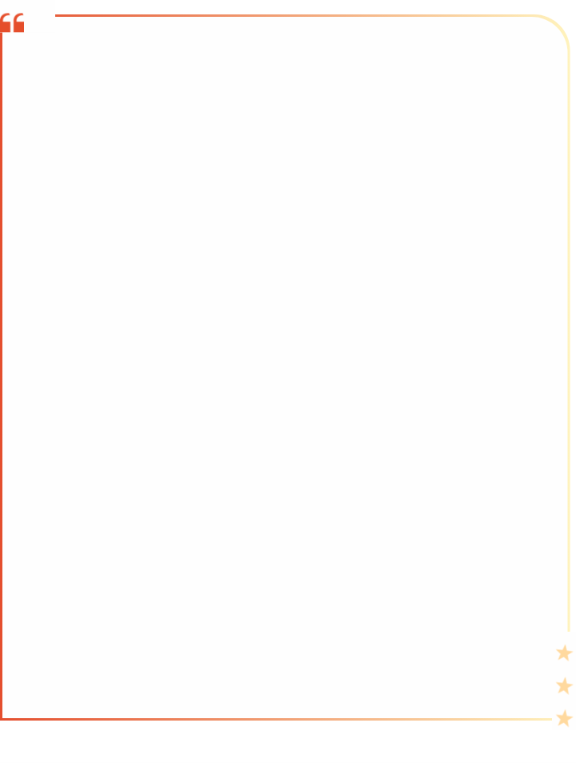

2025中考英语作文押题
【书面表达】常考主题范文6篇
【一】
作为一个中国人，你自豪吗？生长在中国，你幸福吗？请以“My country and I”为题用一到两件具体的事例谈谈你的感受吧。
要求：
（1） 80-120词；
（2）文中不能出现自己的姓名和所在学校班级的名称。
参考信息：
proud/pride...  happy... | live in...life;  study;  sb. who...,sth. that/which...,  economic take-off (经济腾飞)，  in a rapid (快速的)way | I think/believe/suppose...;  make...feel...  take action...
My country and I
As a Chinese，I am extremely proud of my country，Now I'd like to introduce my country to you!
China has achieved remarkable economic growth in a very short period. Take the high-speed railway as an example. It has madetraveling across the country very convenient. I can go fom my hometown to far-away cities in just a few hours. This shows China's rapiddevelopment，Living in China also makes me feel happy. There are so many opportunities for us to leamm and grow. Whether in artscience，or other fields，there are plenty ofresources for us to explore. What's more，Wechat Pay allows us to shop without carrying cash
China is constantly advancing，and I am lucky to be part of it. We should thirst for knowledge and study hard in order to make ourcountry become stronger and stronger
【二】
随着我们国家国际影响力的提升，越来越多的外国人对中国非常感兴趣，包括你的外国朋友Tom，他计划今年来中国过春节，想了解春节期间的一些活动、餐桌礼仪和如何在中国有得体的言行举止。假如你是李华，请根据写作要点提示，给朋友Tom写一封邮件。
写作要点：
1. What activities do we usually have during the Spring Festival?
2. What are the main table manners?
3. How to behave properly in China?
写作要求：
1. 文中须包含写作要点的所有信息，可适当发挥；
2. 文中不得出现考生的真实姓名和学校名称；
3. 用词准确、语句连贯、书写规范、卷面整洁；
4. 词数100左右（开头和结尾已给出，不计入总词数）。
Dear Tom,
I’m glad to know that you’ll spend the Spring Festival in China.The Spring Festival is the most important traditional holiday inChina.
During the festival，there are plenty of activities to take part in. One of the most popular activities is watching New Year party/ galaon CCTV，which is celebrated by all of the Chinese people to welcome the new year.
When it comes to table manners during the Spring Festival，there are a few important things to remember. Firstly，it's polite to waitfor the host to imnvite you to sit down and start eating. Secondly，it's important to respect/ honor the elder people and ofer them the bestdishes first. Finally，it's considered polite to finish the food on your plate and you'd better not to waste food.
As for the Chinese customs. It's important to follow local customs and traditions. People are supposed to shake hands when theymeet for the first time. Also，giving gifts and treating people to have meals is a common rule during festival days.
I hope these tips/ suggestions will help you have a pleasant and enjoyable trip to China.
Looking forward to your coming.
Yours,
Li Hua
【三】
近日，你班针对中学生网上搜索作业答案这一现象举行了一场英语辩论赛（debate）。请以“Should We Search for Answers Online?”为题写一篇短文。结合图文信息，表明你的观点，并阐述理由和举例。
要求：
1．80—120词，题目已给出，不计入总词数;
2．文中不能出现自己的姓名和所在学校名称。
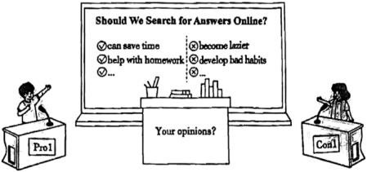
参考信息：

Should We Search for Answers Online?
Recently，our class held an English debate competition to discuss the pros and cons of searching for answers online.
Some students support searching the answers online because they think it can save time. At the same time，in this way we can helpwith homework，which can let us solve the problem in time so that we can continue to finish the rest of the homework.
Different people have different opinions，Other students are against it. They think that if we have problems，we should learn to thinkby ourselves or ask the teacher for help，otherwvise they will become lazier and develop bad habits ofnot thinking.
In my opinion，first we should try our best to finish our homework by ourselves. When necessary，we can turn to the Intemnet for help
【四】
你生活中有烦恼，学习有压力吗？我们应该如何正确面对烦恼，有效缓解心理压力呢？请根据提示以“How to solve our stress”为题写一篇80词左右的短文，开头已给出，不计入字数；语言表达准确规范，语句通顺连贯；提示内容必须用完。
提示：
1. 积极参加体育锻炼，有一个健康的身体；
2. 多与老师、家长和朋友交谈，说出自己的烦恼；
3. 与人和睦相处，多听音乐，多看书；
4. 努力学习，勇敢面对；
5. 你的建议。
注意：
1. 词数：80 词左右；开头已给出，不计入总词数；
2. 应覆盖所有要点；可适当增加细节，使行文连贯；
How to solve our stress
We all have some problems and stress in our lives. How should we solve them?
I think we should take some exercise，so we can keep healthy. We should often communicate with our parents，teachers and friendsby telling them about our problems or stress. We should try to get along well with people around us. We need to relax ourselves，so we canlisten to music，do some reading and so on. We must try our best to study hard and be brave to face our grades，Do something thatinterests us. It will make us feel much better.
【五】
假如你是李华，你上周星期天下午和志愿者们一起参加了去儿童医院慰问孩子们的社会实践活动。请你根据以下提示，给你的父亲写一封电子邮件，向他汇报此次活动的情况。
1. 内容包括：
（1）天气情况及到达医院的方式。
（2）路上买了玩具和水果。
（3）例举你们做了的事情（至少3点）。
（4）孩子们的心情如何。
（5）你们回家后的状态及对活动的看法。
2. 要求：
（1）短文必须包含以上要点，可适当发挥。
（2）意思连贯、符合逻辑、90词左右，电子邮件的开头和结尾已给出，不计入总词数。
（3）文中不能出现真实的学校名和姓名。
参考词汇：
volunteer; Children’s Hospital; on the way to在去……的路上; cheer up; meaningful
Dear dad,
It was sunny last Sunday afternoon. I went to the Children's Hospital with some volunteers. We went there on foot.
On the way to the hospital，we bought them some beautiful toys and fresh fruit. After we got there，we did many things to cheer upthe sick children. Some ofus played games with them. Some ofus told them stories，And some of us sang and danced for them. All thechildren were very happy!
After we got home，we were all tired but happy，We think it's meaningful to do this activity
Yours.
Li Hua
【六】
教育应该培养终身运动者、责任担当者、问题解决者和优雅生活者、某英文网站以 “How to be a better person” 为话题开展征文活动，请从中学生的角度写一篇短文谈谈你的做法。
要点提示：
1.健康生活；
2.不怕挑战；
3.对人友善；
4.承担责任。
要求：
1. 书写清晰、字迹工整；语句通顺；
2. 行文连贯、表达准确；可适当发挥、不少于80词；
3. 文中不得出现真实姓名、校名等信息。
How to be a better person
To be a better person，1 think I should do the following things.
First of all，it's important to be healthy. I will eat more vegetables and fruit instead of junk food. I will also do exercise every day andget enough sleep to stay energetic. What's more，!'l not be afraid to face chalenges anymore and try my best to solve problems in life andstudy，Besides，I should have a good relationship with my family and fiends. Helping others can bring people closer together. Last but notleast，it's our responsibility to take care ofour parents，When I have the ability to give back to society，!'ll do what l can to help the weak
I think the most important thing is to be a usefiul person. lf I start to develop these good habits，I will become a better person andmake a difference in the world.

