
2025中考英语作文押题
【书面表达】热门主题范文6篇
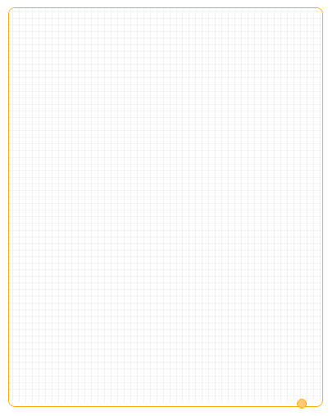
【一】
九年级学生面临中考，学习压力较大。为了高效学习，也为了自己的身体健康，我们都应该学习减压。请以“Learn to lower study pressure”为题并根据要点和要求，写一篇英语短文。
要点：
1）阐述减轻学习压力的重要性；
2）提出两至三种减轻学习压力的方法。
要求：
1）作文应包含所有要点，可适当发挥；
2）文中不得出现真实姓名和学校名称；
3）词数80左右。
Learn to lower study pressure
As ninth-grade students，we take on too much study pressure. We are very tired and sleepy all day，and don't have our own time to dowhat we are interested in. Our life should not be all about getting good grades. We should lear to lower study pressure. Here are threeways for your reference.
First of all，we can listen to our favorite music to have a good sleep at night，Secondly，we can take exercise in spare time to rest ourbrains and eyes. Finally，we can tell our study pressure to others for suggestions on lowering pressure or improving grades.
I hope these ways are helpful to you in lowering study pressure.
【二】
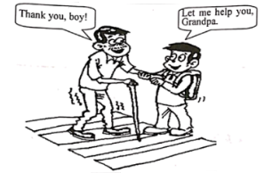
请仔细观察下面的图片，并根据所给提示和要求写一篇短文。

提示：
（1）What are the boy and the old man doing？
（2）What will you do when you see old people ned help?
（3）Why will you do that？
要求：
（1）短文须包括所有提示内容，可适当发挥。
（2）短文中不要出现真实的地名、校名和人名。
（3）词数80个左右（开头已给出，不计入总词数）。
I can see a boy and an old man in the picture. The boy is helping an old man cross the road. When I see old people need help，I wil walkup to them like that little boy and politely say，"Grandpa/Grandma，let me help you." As is known to al，it is our traditional virtue torespect and help the old. When old people need help，each ofus should take the initiative to help them.
【三】
社会的进步需要诚信（honesty and trusty），在平时的生活、学习中，讲“诚信”和不讲“诚信”的事也时有发生。请你写一篇短文谈谈你对诚信的看法。
内容包括：
1.叙述一件你或者身边的家人朋友经历过的有关“守信”或“不守信”的事；
2.谈谈你对诚信的看法，并号召同学要讲诚信。
作文要求：
1.不能照抄原文；不得在原文中出现学校真实的名称和学生的真实姓名；
2.语句连贯，词数80词左右。作文的开头已给出，不计入总词数。
Once upon a time，there was a famous story “"Here Comes the Wolf"，It tells us honesty and trusty is very important.Several days ago，we had an English test. I got a full mark. When I got my paper next day，I found there was a small mistake in my paperBut my teacher didn't se it. Should i tell her the truth? At last I made up my mind to tell her. Not only my teacher but also my classmatespraised me for it. They all said I was an honest boy.
I think honesty and trusty is that we should try our best to do it if we promise something or we can't tell lies and so on. What's more，it can make us happier and our life easier.
【四】
我们的生活中处处充满着爱，有父母的爱，有老师的爱有同学的爱，有朋友的爱……请以“Love around me”为题，写一篇短文。
内容要点如下：
（1）父母为你做早餐，送你上学；
（2）老师传授知识，照顾你；
（3）同学一起学习，和睦相处；
（4）朋友在网上交流，分享快乐与烦恼；
（5）……（自拟一点）。
参考词汇：网上交流chat online
要求：
（1）词数：80～100个
（2）开头已给出，不计入总词数。
（3）要点齐全，行文连贯，可适当发挥。
Love Around Me
There is lots of love around me in my everyday life. Every day I can receive love from my parents,my teachers,my classmates and myfriends.In the morming.my lovely mother cooks delicious food for me.Then my father drives me to school.At school all the teachers notonly look after me well but also teach me lots of useful knowledge.My dear classmates and I study together happily,getting on well witheach other.l chat online with friends in my spare time.They often share my pleasure and trouble.l get love from them.l make a decision tostudy hard and make great progress.Here,[ should say to them,"Thank you for all your love.
【五】
你看过中央电视台董卿主持的节目“朗读者”吗?这是一档非常受欢迎的节目,让我们看到生活中读书的美好,读书的重要。请根据下列表格中所列的要点,以“Growing up with Reading”为题写一篇短文。
读书好 | 1.获取知识,增长见识。
读书好 | 2.让我们自信快乐。
读好书 | 1.读好的书：选择适合自己、能提高自己的书。
读好书 | 2.用好方法读书：读书需要多思考。
 | 1.现状：业余时间看电视、玩网络游戏。
 | 2.建议：养成读书的好习惯,让自己爱上读书。
让读书成为我们生活的一部分,让读书伴随我们成长。
要求：
1.语言表达准确,短文连贯、通顺;
2.短文应包括所有内容,可适当发挥,不要逐句翻译;
3.词数80左右,文章开头部分已给出,不计入总词数。
参考词汇：
get knowledge of,open one's minds,proper books,improve oneself
Have you watched the program The Reader hosted by Dong Qing on CCTV?The program is very popular,and it makes us find reading is useful.
Firstly，reading can help us get knowledge from books. Besides，it can open our minds，which is good for us to study. What's morereading can make us be confident and happy. We all know reading is good，but how can we read books correctly?
First，we should read proper books，which are suitable to us and can improve ourselves. Second，we should read in a good waywhich means we should think more while we are reading. According to a report，many students spend the free time watching and playingcomputer games，and they hardly read books.
In my opinion，we should love reading and develop a good habit ofreading. So let's start reading and make reading a part of our lifeand let's grow up with reading.
【六】
健康胜于一切。均衡的饮食、健康的体魄、利积极的心态、良好的习惯都会给我们带来帮助。假设你是李华，你校英文俱乐部举办题为“Keeping Healthy”的征文活动。请你根据下面的提示写一篇演讲稿，向大家介绍如何保持健康。
内容提示：1. a balanced diet 2. a healthy body and mind 3. good habits
写作要求：
1. 文中不得出现真实的人名、校名 ；
2. 词数80个左右，开头已给出，不计入总词数。
Hello，everyone. I’m Li Hua. Good health is more important than everything.
First，to keep healthy，we need a balanced diet that includes fruits，vegetables，and proteins. Eating the right kinds of food provides uswith essential nutrients. Second，maintaining a heathy body and mind is crucial. Regular exercise and relaxation activities can improveour physical and mental well-being. Lastly，good habits such as geting enough sleep，drinking plenty of water，and maintaining hygieneare essential.
Let's take these steps towards a healthier life. Thank you！

