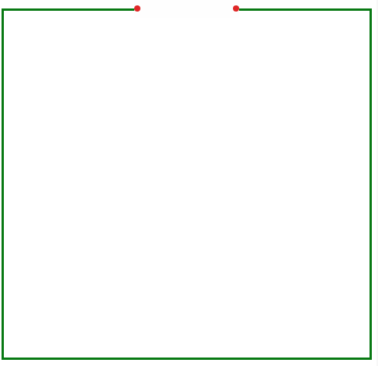
九年级英语【阅读理解】寒假专练

Who says that skirts are only for girls? Men can also wear them. Scotchmen have worn them for many years. They call their skirts kilts. A kilt is a colored skirt. It reaches down to the knee(膝盖). It has different colored checks (方格) on it, like red or blue. Some families in Scotland have their own colors and designs. From the kind of kilt they wear you can tell which group they come from.
The kilt goes back to the 1720s. Scottish soldiers used to wear them. Later, many Scottish men wore them. Today the kilt is not much seen in Scotland. However, in some parts of the country you can still see some older men wearing kilts. Most Scotchman see the kilt as formal dress for national celebrations, marriages or big dinners.
Even kilt makers have moved with the times. Some modern designs have a pocket for a mobile phone.
（ D ）1. Men in ____ wear skirts for many years.
A．Spain B．Korean C．Japan D．Scotland
（ B ）2. A kilt is___________.
A．a kind of beautiful pants B．a kind of skirt with colored checks on it
C．a red or blue dress D．a kind of shorts
（ A ）3. Kilts appeared ________ ago.
A．nearly three hundred years B．hundreds of years
C．thousands of years D．nearly two hundred years
（ C ）4. Which of the following statements isTRUE?
A．Today the kilt is never seen in Scotland.
B．Today more young men like to wear kilts.
C．Today Scotchmen may dress in kilts for formal occasions.
D．Today we can use kilts to call somebody.
（ C ）5. What’s the best title for the passage?
A．Scotchmen B．a kind of beautiful skirt
C．Skirts for men D．The kilts today

九年级英语【阅读理解】寒假专练

Miss Wu is a young teacher of English in China. She loves teaching very much. One day when she was giving an English lesson, she found the headmaster sitting at the back of the classroom. After class, the headmaster told her that he came to her class to find out how much English and how much Chinese she was using. The result was about half English and half Chinese. She was using Chinese when she gave instructions to her students and when she wanted to get feedback（反馈）from her students. The headmaster told her that she should use more English in her class.
Miss Wu made a plan like this: talk with an Englishman every Sunday for two hours to learn more English expressions;write some English expressions on cards. These cards not only remind her to use English in class, but also help her remember some expressions;have a five-minute talk in English with students before class.
She used body language to help her if students could not understand.
One year later, she found she could use English freely in class.
（ C ）1. Miss Wu ______.
A．has a poor memory B．is a teacher of Chinese
C．loves her job D．is angry with the headmaster
（ B ）2. The headmaster came to Miss Wu’s class to ______.
A．write some English expressions on cards
B．help her improve her English teaching
C．give instructions to the students
D．get feedback from the students
（ B ）3. After the headmaster left, Miss Wu realized that she should _____ in her class.
A．use more Chinese B．use more English
C．use half English and half Chinese D．use body language
（ A ）4. What does the underlined word “remind” mean?
A．提醒 B．阻止 C．宽恕 D．依赖
（ C ）5. What is the main idea of this passage?
A．Use cards in English teaching B．Talk with English-speaking people
C．Speak more English in English class D．Learn more English expressions

九年级英语【阅读理解】寒假专练

Why do we need to throw less away? There are two reasons. One is that some resources （资源） are nonrenewable （不可再生的） That means there is only a certain amount of that resource in the world . One example of this is oil. When we use up all the oil in the world, there will be no more.
There is another reason for throwing less away. All of our trash has to be put somewhere. Often , it is put into garbage dumps （垃圾场）. Much of that trash will be there for hundreds of years. The dumps will be filled up with all this trash.
There are three ways to cut down on trash.
One way is to recycle. When you recycle something, it means it is made into another shape and used again. Old newspaper may become paper bags. A glass jar can be melted（熔化）and made into a bottle .
Another way to cut down on trash is to reuse things. You can wash and use again a bottle that can hold mustard （芥末酱）or something else .
The third way to cut down on trash is to reduce the amount of trash you make, stop buying thing that you don’t need in the first place. That reduce the amount of the earth’s resources that you use.
（ C ）1. How many reasons do we need to throw less away?
A．Three B．five C．two
（ B ）2. When you reuse something, it means .
A．it is made into another shape and used again
B．it is used again C．it isn’t used any more
（ C ）3. All the ways of cutting down on trash in the passage are to .
A．recycle and reuse things
B．recycles and reduce the amount of trash you make
C．reuse things recycle and reduce the amount of trash you make
（ A ）4. If a broken plastic box is changed into a plastic ruler , the way is to .
A．recycle B．reuse C．reduce
（ B ）5. The word “reduce” in the passage means .
A．还原 B．减少 C．增加

九年级英语【阅读理解】寒假专练
Once upon a time there was a monster. He was very ugly）（丑陋的）, and had no friends. No one wanted to talk to him. Even other monsters thought he was ugly.He lived alone and was very unhappy because he was so lonely.
“I wish I had a friend.” he said to himself every day. “One friend would be enough. Someone to talk to.”
“Dear Editor.” he wrote. “ I am an ugly monster. How can I find a friend?”
“Dear Monster.” the Editor replied. “ Advertise（登广告）for a friend in this magazine.”
The monster wrote an advertisement（广告）.
“Monster wants a friend, male or female. I have two heads, four arms, six legs and three tails. I have one blue eye, one green eye and one brown eye. Smoke comes out of my noses. But I am really a kind monster and will be a good friend to someone. If you would like to meet me, please stand outside Blake’s Store at 6 p.m. on Friday, May 22nd. Write to me at Box 45. Everybody’s Magazine.”
A few days later he went to the magazine.
“Do you have any letters for Box 45?” he asked.
The Editor looked in Box45.
“Yes, there is one.” she said, and gave it to him.
The monster opened the letter, and read, “Dear Monster, I think a person’s character（品行）is more important than his appearance. I will wait outside Blake’s Store on Friday. Please carry a flower so that I will recognize you. Yours sincerely, Miss Alice Thwaite.”
（ A ）1. Why was the monster unhappy?
A．He had no friends. B．He was ugly.
C．He had two heads. D．He had three tails.
（ B ）2. What did the monster advertise for?
A．A magazine B．A friend C．An editor D．A male monster
（ C ）3. How did the monster describe himself in the advertisement?
A．Bad B．Lonely C．Kind D．Different
（ A ）4. What was wrong about Miss Thwaite’s letter?
A．She was interested in people’s appearances.
B．She wanted to meet the monster.
C．She needed a flower to recognize him by D．It was the only reply

