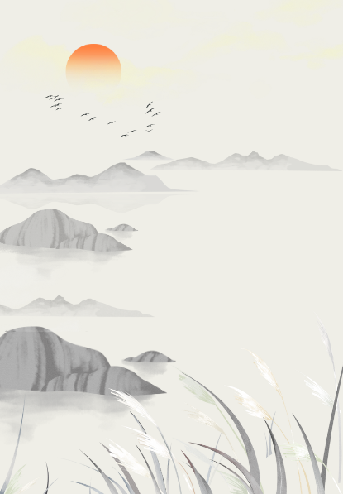
七下英语 | 完形填空寒假培优练习
①
Dear Annie，
Thank you for your letter. I’m glad you like your schoo1. I want to tell you about my life here.
I go to school from Monday ____ Friday. Our lessons ____ at eight o’clock. We have four classes in the morning and three classes in the afternoon. We have many things ____after class. On Monday and Wednesday afternoon we have sports. On Tuesday afternoon some of____read books happily in the ____ On Friday afternoon we practice ____ English. My Chinese friends would like ____ with me in English. They think I am ____ an English teacher. Isn’t it great?
On Saturdays and Sundays I ____ not go to schoo1. I can go to the park or do DIY jobs at home.
Yours,
Henry
（A）1.A．to B．on C．for D．with
（A）2.A．begin B．have C．finish D．play
（D）3.A．doing B．does C．do D．to do
（B）4.A．we B．us C．them D．they
（A）5.A．Reading Club B．Art Club C.Swimming Club D.Singing Club
（D）6.A．speak B．to speak C．speaks D．speaking
（A）7.A．to chat B．chat C．chats D．chatting
（C）8.A．liking B．likes C．like D．to like
（A）9.A．do B．am C．is D．are
（D）10.A．All right B．Very good C．Thank you D．All the best
七下英语 | 完形填空寒假培优练习②
American____begins in September after a long____holiday. There are two terms in a school____The first term is from____to January, and____is from February to June. Most American children begin to go to school when they are five years old. Most students are seventeen to eighteen years old when they finish high school.
High school students in America take only five or six ___ each term. They usually go to the same class every day, and they have homework ___ every class. After class they do all kinds of interesting things.
After high school, many students go to college(大学). They can go to a small or a large one. They usually have to give____money. So, many____students work after school ____ money for their studies.
（B）1.A．student B．school C．class D．teacher
（C）2.A．winter B．autumn C．summer D．spring
（D）3.A．day B．week C．month D．year
（C）4.A．July B．August C．September D．October
（C）5.A．two B．a second C．the second D．second
（D）6.A．hours B．lesson C．schools D．subjects
（B）7.A．in B．for C．to D．on
（D）8.A．many B．a few C．a little D．a lot of
（C）9.A．school B．high school C．college D．middle school
（A）10.A．to get B．to take C．to borrow D．to give
七下英语 | 完形填空寒假培优练习③
All over the world people enjoy sports. Sports help people to keep_______, happy and to live_______People play different games in winter and summer_______is good for swimming. And in winter people often go skating. Some sports are very_______and people everywhere like them. For example, football is very popular. In China, most people, men,_______,boys and girls, like to watch football games. They often talk about them._______and jumping began long, long ago. But basketball and volleyball are rather_______People began to play them not long ago. And people are_______new sports or games all the time. Water skiing is one of_______People________different countries may not be able to understand each other, but after a game they often become friends.
（C）1.A．health B．busy C．healthy D．lazy
（B）2.A．long B．longer C．happy D．happily
（B）3.A．Winter B．Summer C．Auturnn D．Spring
（D）4.A．boring B．difficult C．expensive D．interesting
（B）5.A．woman B．women C．old D．young
（C）6.A．Run B．Runs C．Running D．To run
（A）7.A．new B．interesting C．popular D．old
（C）8.A．start B．play C．playing D．starting
（D）9.A．oldest B．newest C．the oldest D．the newest
（C）10.A．on B．of C．from D．at
七下英语 | 完形填空寒假培优练习④
I have a friend, Linda. Linda is ____ girl. She is____ years old. She lives with ____ parents .She studies in a middle school near her home. Her classes begin at eight o’clock in the morning. She usually ____at six thirty in the morning. And she washes ____ seven fifteen. Then she has breakfast. She ____school at seven thirty. In the afternoon, the classes begin at two o’clock. There are only two ____in the afternoon. She can ____ at five o’clock. In the evening, she usually ____her homework and watches TV. She goes to____ bed at 10:30.
（D）1.A．a America B．a Australian C．an England D．an English
（C）2.A．third B．three C．thirteen D．thirty
（B）3.A．she B．her C．his D．hers
（A）4.A．gets up B．get up C．gets on D．is getting up
（C）5.A．in B．on C．at D．for
（B）6.A．go to B．goes to C．goes D．to go
（C）7.A．class B．friends C．classes D．game
（C）8.A．goes to home B．go to school C．goes home D．go home
（C）9.A．is doing B．to does C．does D．do
（A）10.A．/ B．the C．a D．an

