2025新教材 | 七年级英语下册
Unit 1-8作文范文集锦
Unit 1 Animal Friends
动物是人类的朋友，所以许多人喜欢养宠物。请你写一篇英语短文讲讲你最喜欢的一个宠物。
内容要点包括：
1. 你最喜欢的宠物以及原因；
2. 这个宠物的外貌特征、爱好、生活习性、你和它的活动；
3. 呼吁人们保护动物。
作文要求：
1. 不得在作文中出现学校的真实名称和学生的真实姓名。
2. 语句连贯，词数 80 个左右。
参考范文：
Animals are our friends, so many people like to keep a pet. My favorite pet is the dog. Because the dogs are very smart and loyal. They can accompany the lonely people.
The dogs have different colors like white, black, yellow and so on. They are very lovely and naughty. They run here and there. And they like with people, so I always take my dog to go for walk after dinner.
Dogs bring us happiness and make us relax. We should protect animals, they are our friends. And they have their life, we can't hurt them.
2025新教材 | 七年级英语下册
Unit 1-8作文范文集锦
Unit2 No Rules, No Order
从假如你是李华，你的笔友Robert将到你家做客，体验中国生活。请根据提示，给Robert写封建议信。提示：餐桌礼仪（至少两项）；家规（至少两项）；与他人交往等。
注意：
1. 信文须包括提示所有要点。
2. 可根据要点适当增加，使行文连贯。
3. 书写规范，卷面整洁。
4. 词数100词。文章开头结尾已给出，不计在词数内。
参考范文：
Dear Robert,
You must be excited about coming to China soon. I will share some Chinese manners with you.
When you eat dinner with other people, it’s rude to point at others with your chopsticks. When you finish eating, you mustn't stick your chopsticks into the bowl.
My parents are very strict with me, and they have made some rules which I must obey. Firstly, I must finish my homework in time. Secondly, I can’t play computer games, even in my free time or on weekends.
When you meet a Chinese person for the first time, you should shake hands. It’s polite to call first if you want to visit your friends.
I hope that you will enjoy yourself in China.
Best wishes,
Li Hua
2025新教材 | 七年级英语下册
Unit 1-8作文范文集锦
Unit3 Keep Fit
假如你是王云，你们班要召开一次以“健康”为主题的班会。请你根据提示用英语写一篇短文，介绍你的朋友李明的健康生活。
参考要点：
1. 吃健康食物：牛奶、鸡蛋、水果、蔬菜……
2. 不吃垃圾食品 (junk food)：汉堡、炸鸡 (fried chicken)、冰激凌……
3. 喜欢运动：踢足球、打排球、打乒乓球……
要求：
1. 60-80词左右，可适当发挥，开头已给出，不计入总词数；
2. 文中不能出现自己的姓名和所在学校的名称。
参考范文：
Li Ming is my good friend. He has good eating habits. He always has milk, eggs, fruit and vegetables. But he doesn’t eat hamburgers, fried chicken or ice cream. He thinks they are not healthy. He loves sports, too. He can play soccer, volleyball and ping-pong. He plays them with his classmates after school every day. They are fun and easy for him. Li Ming thinks healthy food and sports are good for him. So he is always healthy.
2025新教材 | 七年级英语下册
Unit 1-8作文范文集锦
Unit4 Eat Well
“民以食为天”，饮食的安全和健康受到越来越多地关注和重视。请你以“Say No to Junk Food”为题，根据以下要点写一篇英语短文。
写作要点：
1）垃圾食品尽管美味，但对健康无益，而且其过多的包装会产生更多的垃圾；
2）远离垃圾食品，还应选择正确的生活方式，如：
① 三餐要有规律、少吃零食、快餐；② 多吃蔬菜、水果等健康食物，以提供身体必需营养；③ 多参加户外活动……
写作要求：
1）词数：80左右，开头与结尾已写出，不计入总词数；
2）内容必须包括上述所有要点，可适当进行发挥；
3）参考词汇：过多包装over packaging；有规律地regularly；营养nutrition
参考范文：
Say No to Junk Food
Nowadays,more and more attention has been paid to food safety and health. As far as I am concerned, we should say no to junk food. There is no doubt that junk food is made delicious and attractive, but is surely does harm to our body. Meanwhile, the over packaging necessarily leads to much more rubbish.
To get away from the junk food, we should focus on how to keep a healthy lifestyle. There are many tips to follow. First, eat regularly, three meals a day on time. Try as few snacks of fast food as possible. Second, take more fruits and vegetables which can provide the nutrition we need. What’s more, do more outdoor activities, as long as you are busy with something interesting, you will more probably get away from junk food.
In a word, a healthy diet with less junk food can help make us stronger and stronger.
2025新教材 | 七年级英语下册
Unit 1-8作文范文集锦
Unit5 Here and Now
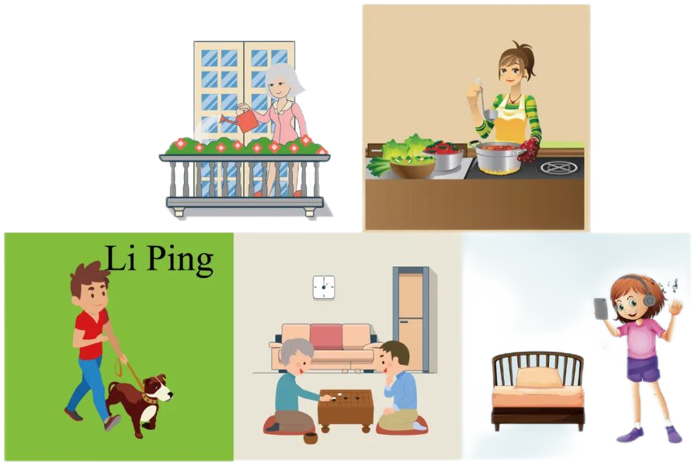
从假如你是李平，请根据所给的图片和参考词汇完成写给好朋友Jim的信件。

写作要求：
1. 邮件必须描述图片中所有人物正在做的事，可适当增加细节：
2. 有一个用and连接的并列句：
3. 文中不得出现真实的姓名和校名，词数60左右。
参考词汇：
walk the dog, water the flowers, listen to the music
参考范文：
Dear Jim,
Here is a picture a my family. We are all at home now. My mother is busy. She is cooking dinner in the kitchen. My grandmother is watering the flowers and My grandfather is chess with my father in the living room. My sister is listening to the music in her room. I am walking the dog in the garden. We’re having a good time. Can you show me your family pictures?
Yours,
Li Ping
2025新教材 | 七年级英语下册
Unit 1-8作文范文集锦
Unit6 Rain or Shine
假如你是李明，是学校的播音员，你每天为学校播报天气信息，下面表格列出了三天的天气，请为大家播报。
要求：
1．70词以上（文章开头和结尾已给出，不计入总词数）；
2．必须包括表格内容，可适当增加细节，以使行文连贯；
3．文中不得出现真实姓名、校名和地名。
参考词汇：do housework
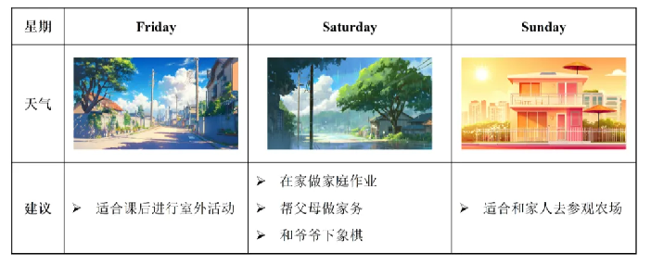

参考范文：
Good morning, boys and girls! I’m Li Ming. Now I’d like to tell you the weather on Friday, Saturday and Sunday.
It’s cloudy on Friday. So it’s cool. It’s a good time to play basketball after class. But on Saturday, it’s a rainy day. You can stay at home to do your homework. And you can help your parents to do housework. Then you can play chess with your grandfather. On Sunday, it’s a sunny day. You can go to the farm with your family.
That’s all. Thank you for your listening！
2025新教材 | 七年级英语下册
Unit 1-8作文范文集锦
Unit7 A Day to Remember
假如你是中学生Jerry，你今天参加了学校组织的旅行，你感到特别开心，收获很多，并体会到参加学校旅行给你带来的好处。请写一篇日记，记录今天发生的一切。
写作要点：
1. 表达你觉得这次活动很有意义
2. 介绍这次旅行的基本情况
1）出行方式和目的地：学校巴士，太阳岛
2）沿途所见：（农场，村庄，松花江）
3）参加的活动：（游戏，照相，做农活）
3. 请谈谈你参加此次学校旅行的好处
参考范文：
July 1st, Friday Sunny
I am excited today because I have a school trip. It was such a meaning and funny experience. I feel so grateful that our school organized this trip for us. Today’s trip started with a school bus ride to Sun Island. The scenery along the way was breathtaking. We passed by farms, villages, and the Songhua River. The view was so peaceful and beautiful. Upon arriving at Sun Island, we were welcomed by the warm sunshine and fresh air. We started our day with some team-buliding games. It was a great opportunity for us to bond with our classmates and teachers. We also took lots of pictures to remember this special day. Later in the day, we had the chance to experience farm work. It was hard work, but it was rewarding. It made me appreciate the farmers who work tirelessly to provide us with food.
This school trip has been a great benefit to me. It allowed me to learn more about nature and agriculture, and it also strengthened the bond between me and my classmates.
2025新教材 | 七年级英语下册
Unit 1-8作文范文集锦
Unit8 Once upon a Time
同学们对“愚公移山”的故事一定有着很深的印象吧？请根据下面的图片及提示词语，以The story of Yu Gong为题，把“愚公移山”的故事用英语简要叙述一下，并谈一谈你从故事中学到了什么。100词左右，开头已给出，不计入总词数。
提示词语：
move the mountains, start digging, Zhi Sou, it is impossible...,
die, sons, grandsons, continue to move, god, be moved, help, the story reminds us ...

参考范文：
The story of Yu Gong
Once there lived an old man called Yu Gong. Two high mountains stopped his family from walking to the other side. So Yu Gong decided to move the mountains.
Although Yu Gong was old, he decided to move the mountains with his family. So Yu Gong started digging. At that time, a “clever” man called Zhi Sou laughed at him and told him that it was impossible to move such high mountains. But Yu Gong didn’t listen to him and said that his sons and grandsons would continue to move the mountains after he died. Then a god was moved by Yu Gong so he sent two gods to help him move the mountains.
The story reminds us that nothing is impossible as long as we work hard. We should not give up.

