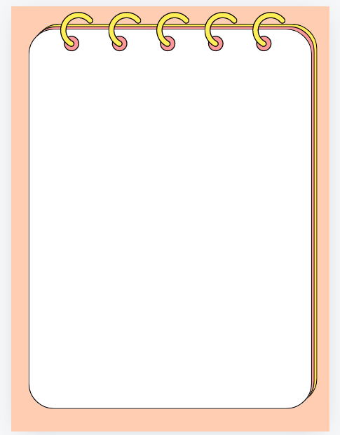

八升九 | 暑假预习
九年级英语全一册
Unit1-14重要句型

九年级英语全一册Unit1-14重要句型

Unit 1 How can we become good learners?
询问方法句型：How can + 主语 + do sth.?
【例句】How can we become good learners?（我们怎样才能成为好的学习者？）
“by + 动名词”表示方式
【例句】I learn English by listening to tapes.（我通过听磁带学习英语。）
“find it + adj. + to do sth.” 结构
【例句】I find it interesting to learn English.（我发现学英语很有趣。）
“the + 比较级，the + 比较级” 表示 “越……，越……”
【例句】The more you read, the faster you'll be.（你读得越多，就会读得越快。）
Unit 2 I think that mooncakes are delicious!
表达观点句型：I think / believe / suppose / guess that...
【例句】I think that mooncakes are delicious!（我觉得月饼很美味！）
“not...until...” 直到…… 才……
【例句】He didn't go to bed until his mother came back.（直到他妈妈回来他才睡觉。）
“look forward to (doing) sth.” 期待（做）某事
【例句】I'm looking forward to the holiday.（我期待着这个假期。）
Unit 3 Could you please tell me where the restrooms are?
委婉请求句型：Could you please tell me...?
【例句】Could you please tell me where the restrooms are?（你能告诉我洗手间在哪里吗？）
“whether / if + 宾语从句” 是否……
【例句】I don't know whether / if he will come tomorrow.（我不知道他明天是否会来。）
“lead sb. to sp.” 带领某人去某地
【例句】The sign leads us to the museum.（这个标志指引我们去博物馆。）
Unit 4 I used to be afraid of the dark.
“used to do sth.” 过去常常做某事
【例句】I used to be afraid of the dark.（我过去常常害怕黑暗。）
“be afraid of sth. / doing sth.” 害怕某物 / 做某事
【例句】She is afraid of speaking in public.（她害怕在公众面前讲话。）
“take up doing sth.” 开始从事某事
【例句】He took up painting last year.（他去年开始从事绘画。）
Unit 5 What are the shirts made of?
询问材质句型：What are / is... made of?
【例句】What are the shirts made of?（这些衬衫是由什么制成的？）
“be made from” 由…… 制成（看不出原材料）
【例句】Paper is made from wood.（纸是由木头制成的。）
“be famous for” 因…… 而著名
【例句】China is famous for tea.（中国因茶而著名。）
Unit 6 When was it invented?
询问时间句型：When was / were... invented?
【例句】When was it invented?（它是什么时候被发明的？）
被动语态 “be + 过去分词”
【例句】The telephone was invented by Bell.（电话是由贝尔发明的。）
“by accident” 偶然地
【例句】I found this old photo by accident.（我偶然发现了这张旧照片。）
Unit 7 Teenagers should be allowed to choose their own clothes.
表达允许句型：sb. should / shouldn't be allowed to do sth.
【例句】Teenagers should be allowed to choose their own clothes.（青少年应该被允许选择他们自己的衣服。）
“be serious about” 对…… 认真
【例句】He is serious about his study.（他对学习很认真。）
“get in the way of” 妨碍
【例句】Don't let your hobby get in the way of your schoolwork.（不要让你的爱好妨碍了你的学业。）
Unit 8 It must belong to Carla.
推测句型：must / might / could / can't + 动词原形
【例句】It must belong to Carla.（它一定属于卡拉。）
“run after” 追逐
【例句】The dog is running after the cat.（狗正在追猫。）
“attend a concert” 参加音乐会
【例句】I attended a concert last night.（我昨晚参加了一场音乐会。）
Unit 9 I like music that I can dance to.
定语从句 “that / which / who 引导的定语从句”
【例句】I like music that I can dance to.（我喜欢我能跟着跳舞的音乐。）
“prefer A to B” 比起 B 更喜欢 A
【例句】I prefer classical music to pop music.（比起流行音乐，我更喜欢古典音乐。）
“remind sb. of sth.” 使某人想起某事
【例句】This song reminds me of my childhood.（这首歌使我想起了我的童年。）
Unit 10 You 're supposed to shake hands.
“be supposed to do sth.” 应该做某事
【例句】You're supposed to shake hands.（你应该握手。）
“make a mistake” 犯错误
【例句】I made a mistake in the exam.（我在考试中犯了一个错误。）
“get used to (doing) sth.” 习惯于（做）某事
【例句】He has got used to living in the city.（他已经习惯了在城市生活。）
Unit 11 Sad movies make me cry.
“make sb. do sth.” 使某人做某事
【例句】Sad movies make me cry.（悲伤的电影使我哭泣。）
“leave sb. alone” 不管 / 不理某人
【例句】Leave me alone. I want to be alone.（别管我。我想一个人待着。）
“rather than” 而不是
【例句】I would rather stay at home than go out.（我宁愿待在家里也不愿出去。）
Unit 12 Life is full of the unexpected.
“be full of” 充满
【例句】Life is full of the unexpected.（生活充满了意外。）
“by the time” 到…… 时候为止
【例句】By the time I got to school, the bell had rung.（到我到达学校的时候，铃已经响了。）
“give sb. a lift” 捎某人一程
【例句】Can you give me a lift to the station?（你能捎我一程去车站吗？）
Unit 13 We're trying to save the earth!
“try to do sth.” 尽力做某事
【例句】We're trying to save the earth!（我们正在尽力拯救地球！）
“play a part in” 在…… 中起作用
【例句】Everyone should play a part in protecting the environment.（每个人都应该在保护环境中起作用。）
“turn off” 关闭
【例句】Please turn off the lights when you leave the room.（离开房间时请关灯。）
Unit 14 I remember meeting all of you in Grade 7.
“remember doing sth.” 记得做过某事
【例句】I remember meeting all of you in Grade 7.（我记得在七年级见过你们所有人。）
“regard...as...” 把…… 看作……
【例句】We regard him as our friend.（我们把他看作我们的朋友。）
“be thankful to sb.” 感谢某人
【例句】I'm thankful to my teachers for their help.（我感谢老师们的帮助。）

