五年级英语上册
《句型与语法》练习专项试卷带答案
时间：60分钟 满分：100分
题号 | 一 | 二 | 三 | 四 | 五 | 六 | 七 | 八 | 九 | 十 | 总分
得分

一、根据句子选择正确的图片。(10分)
( B )1. I often play the pipa on Sundays.
A. 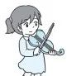 B. 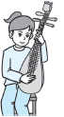
( B )2. We'll learn some kung fu.
A. 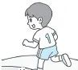 B. 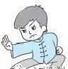
( A )3. What a nice family photo!
A. 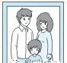 B. 
( B )4. There is a desk beside the bed.
A. 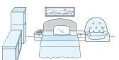 B. 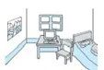
( A )5. We can take some pictures here.
A. 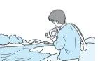 B. 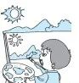

二、给句子选择正确的图片。(10分)
A. 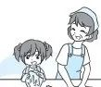B. C. D. 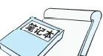E. 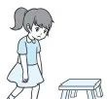
( B ) 1. Our head teacher is strict.
( D ) 2. I need to buy some notebooks.
( A ) 3. I have a cooking class with my grandma.
( E ) 4. She looks tired.
( C ) 5. Our PE teacher is a good football player.

三、单项选择。(10分)
( A ) 1. Is there a river ________ the mountain?
A. in front of B. in front C. in the front

( B ) 2. Sarah's favourite food ________ ice cream.
A. am B. is C. are

( C ) 3. We ___ English, maths and PE this afternoon.
A. has B. don't C. have

( B ) 4. I have ________ English class at 4 o'clock.
A. a B. an C. /

( C ) 5. What can you do ________ the party?
A. above B. with C. for

( C ) 6. Lily can play________ erhu.
A. an B. / C. the

( C ) 7. Look at these ________. They are delicious.
A. sandwich B. sandwichs C. sandwiches

( B ) 8. There ___ a park and some shops near my home.
A. have B. is C. are

( A ) 9. We like salad ________ not carrots.
A. but B. and C. with

( A ) 10. There aren't ________ birds in the park.
A. any B. some C. a

四、读一读，用所给词的适当形式填空。(10分)
1. We are (be) helpful at home.
2. They don't (not) have enough money.
3. I read books (book) in the evening .
4. Onions (onion) are my favourite food.
5. Sarah plays pingpong very well (good).
6. He can play (play) the piano for the party.
7. There is (be) some milk on the table.
8. Do you have (have) a dancing class on Saturdays ?
9. Can you do any(some) kung fu?
10. I would like o eat (eat)some noodles.

五、给下列问句选择正确的答语。(10分)
( C ) 1. Can you sing and dance?
( B ) 2. Is there a river in the village?
( E ) 3. What's your PE teacher like?
( D ) 4. Do you often play basketball?
( A ) 5. I can swim. What about you？

六、根据图片提示，写出问句或答语。(10分)
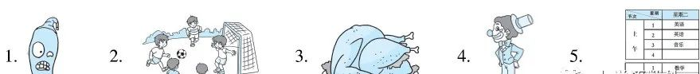
1. —Is it hot?
—Yes, it is.

2. —Do you often play football on the weekend?
—Yes, I do.

3. —What would she like?
—She'd like some chicken.

4. —What's he like?
—He is funny.

5. —What do you have on Tuesday?
—We have English, maths and music.

七、读对话，根据对话内容补全句子。(10分)
1. A: What's your mother like?
B: She is tall and thin, and she is kind.
My mother is tall, thin and kind.

2. A: What do you often do on Saturdays?
B: I often play computer games.
I often play computer games on Saturdays.

3. A: Do you have a football class on Mondays, Peter?
B: No, I have a basketball class.
Peter has a basketball class on Mondays.

4. A: What would you like to drink ?
B: I'd like some tea. It's healthy and delicious.
I'd like some tea， because it's healthy and delicious.

5. A: Is there a water bottle in your room?
B: Yes, there is. It's near the computer.
There is a water bottle near the computer.

八、连词成句。(10分)
1. homework often on I do Sundays my (. )
I often do my homework on Sundays.

2. your who's teacher music (？)
Who's your music teacher?

3. fish today we sandwiches have and(. )
We have fish and sandwiches today.

4. you Chinese can speak English or (？)
Can you speak Chinese or English?

5. on the computer the is desk(. )
The computer is on the desk.

九、按要求完成下列各题。(10分)
1. I can dance with you. (改为一般疑问句)
Can you dance with me?

2. A football is under the desk. (对画线部分提问)
What is under the desk?

3. I often watch TV on Sundays. (改为一般疑问句)
Do you often watch TV on Sundays?

4. Are there any trees in the park？(给出否定回答)
No, there aren't.

5. I'd like some beef noodles. (对画线部分提问)
What would you like?

十、选择合适的选项补全对话。(10分)
A: Excuse me! 1. B
B: I often help my mother do some housework on the weekend.
A: 2. E
B: I can wash the clothes.
A: 3. D
B: No，I can't cook lunch but 4. A
A: Good! You are helpful. What's your favourite food?
B: 5. C My mother often cooks it.
A: Cool.
A. I can clean the window.
B. What do you often do on the weekend?
C. My favourite food is fish.
D. Can you cook lunch?
E. What can you do?

