八下英语 | 期末复习专练
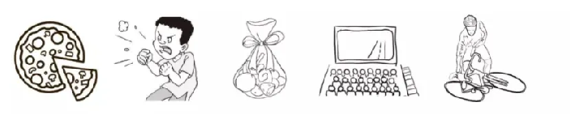
【看图写话】训练

1. taste, delicious ：The pizza tastes delicious.
2. seem to ：He seems to be angry.
3. filled, candy ：The bag is filled with candy.
4. go to, Sunday ：We are going to see a movie on Sunday./We went to see a movie last Sunday.
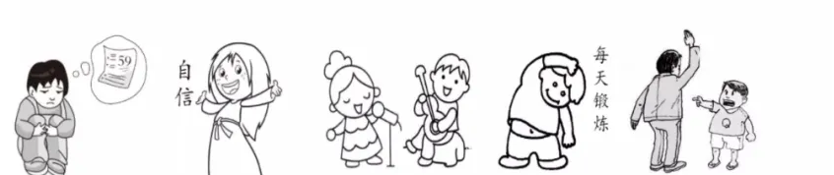
5. fall off, yesterday :He fell off the bike yesterday.

6. upset, because ：He felt upset because he failed the exam.
7. should, about ：You should be confident about yourselves.
8. while ：The girl is singing while the boy is playing the guitar.
9. be used to ：I am used to exercising every day.
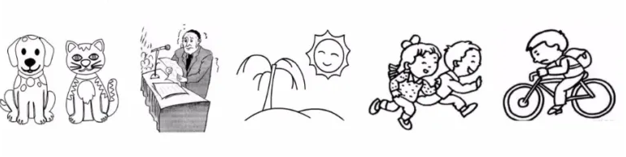
10. strict, son ：The man is strict with his son.

11. as... as..., lovely ：The dog is as lovely as the cat.
12. nervous, when ：He often feels nervous when giving a speech.
13. picnic, if ： If it's sunny tomorrow, we'll go for a picnic.
14. not so...as ： The girl doesn't run so fast as the boy.
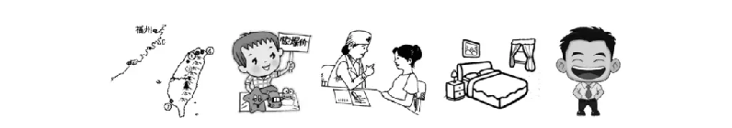
15. ten minutes, school ：It takes him ten minutes to ride to school./It takes him ten minutes to go to school by bike.

16. Taiwan, lie ：Taiwan lies to the southeast of Fujian.
17. sell, raise ： The boy sells toys to raise money.
18.advise, rest ：The doctor advised her to have a rest.
19. book, with ： I'd like to book a room with one bed.
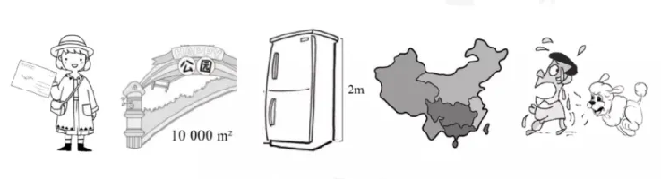
20. can't help ：He can't help laughing.

21. receive, friend ：She received a postcard from her friend.
22. cover, meter ：The park covers an area of 10000 meter squares.
23. meter, tall ：The fridge is two meters tall.
24. lie, Asia ： China lies in the east of Asia.
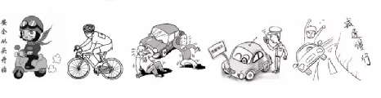
25. afraid ：He is afraid of the dog.

26. important, wear ： It's important to wear a helmet when riding.
27. not, pollution ： Bicycle riding/Cycling does not cause air pollution.
28. badly hurt, in ：The old man is badly hurt in a traffic accident.
29. get, fine ：The driver got a fine because he parked in the wrong place.
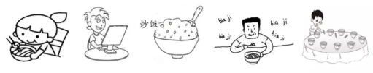
30. never, fast： Never drive too fast.

41.noodles, with：She eats noodles with chopsticks.
42.touch, Internet：The boy gets in touch with his friends on the Internet.
43.favorite：My favorite food is fried rice.
44. impolite, noisily：It's impolite to eat noisily in China.
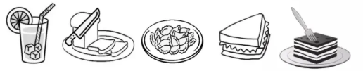
45. help, set：He often helps his mom to set the table.

46. would like：I would like a glass of lemon juice.
47. cut, piece：Please cut the bread into pieces.
48. taste：The dumplings taste delicious.
49. mind, teach： Would you mind teaching me to make a sandwich?.
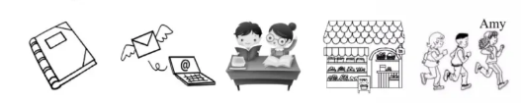
50. use, eat：We can use fork to eat cake.

51. worth, read ：The book is worth reading.
52. send, later on： I'll send you the letter later on.
53. carefully, than： The boy reads more carefully than the girl.
54. for sale：There are a lot of things for sale.
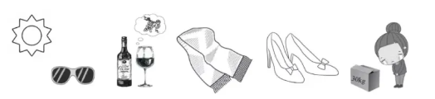
55. fast, three：Amy runs the fastest of the three.

56. protect, from：The sunglasses can protect us from the sun.
57. be made, grape ：The wine is made from grapes.
58. be made, silk：The scarf is made of silk.
59. buy, leather：I want to buy a pair of leather shoes.
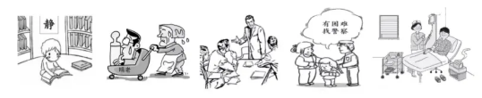
60. so, that：The box is so heavy that she can't carry it.

61. right, keep： It's right to keep quiet in the library.
62. always, depend：We can't always depend on our parents.
63. suitable, wear：It's suitable to wear a business suit at the meeting.
64. get help, when：We can get help from the police when we're in trouble.
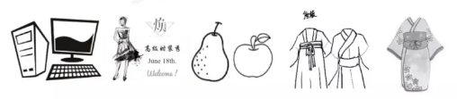
65. job, look after：The nurses'/ Her job is to look after patients.

66. everyone, personal：Everyone has a personal computer.
67. there be：There is a fashion show on June 18th.
68. like, both ：I like both pears and apples.
69. stand for, culture：The Tang costume stands for Chinese culture.
70. Kimono, traditional：Kimono is Japanese traditional costume.
八下英语 | 期末复习专练
【看图写话】训练

1. taste, delicious ：The pizza tastes delicious.
2. seem to ：He seems to be angry.
3. filled, candy ：The bag is filled with candy.
4. go to, Sunday ：We are going to see a movie on Sunday./We went to see a movie last Sunday.
5. fall off, yesterday :He fell off the bike yesterday.

6. upset, because ：He felt upset because he failed the exam.
7. should, about ：You should be confident about yourselves.
8. while ：The girl is singing while the boy is playing the guitar.
9. be used to ：I am used to exercising every day.
10. strict, son ：The man is strict with his son.

11. as... as..., lovely ：The dog is as lovely as the cat.
12. nervous, when ：He often feels nervous when giving a speech.
13. picnic, if ： If it's sunny tomorrow, we'll go for a picnic.
14. not so...as ： The girl doesn't run so fast as the boy.
15. ten minutes, school ：It takes him ten minutes to ride to school./It takes him ten minutes to go to school by bike.

16. Taiwan, lie ：Taiwan lies to the southeast of Fujian.
17. sell, raise ： The boy sells toys to raise money.
18.advise, rest ：The doctor advised her to have a rest.
19. book, with ： I'd like to book a room with one bed.
20. can't help ：He can't help laughing.

21. receive, friend ：She received a postcard from her friend.
22. cover, meter ：The park covers an area of 10000 meter squares.
23. meter, tall ：The fridge is two meters tall.
24. lie, Asia ： China lies in the east of Asia.
25. afraid ：He is afraid of the dog.

26. important, wear ： It's important to wear a helmet when riding.
27. not, pollution ： Bicycle riding/Cycling does not cause air pollution.
28. badly hurt, in ：The old man is badly hurt in a traffic accident.
29. get, fine ：The driver got a fine because he parked in the wrong place.
30. never, fast： Never drive too fast.

41.noodles, with：She eats noodles with chopsticks.
42.touch, Internet：The boy gets in touch with his friends on the Internet.
43.favorite：My favorite food is fried rice.
44. impolite, noisily：It's impolite to eat noisily in China.
45. help, set：He often helps his mom to set the table.

46. would like：I would like a glass of lemon juice.
47. cut, piece：Please cut the bread into pieces.
48. taste：The dumplings taste delicious.
49. mind, teach： Would you mind teaching me to make a sandwich?.
50. use, eat：We can use fork to eat cake.

51. worth, read ：The book is worth reading.
52. send, later on： I'll send you the letter later on.
53. carefully, than： The boy reads more carefully than the girl.
54. for sale：There are a lot of things for sale.
55. fast, three：Amy runs the fastest of the three.

56. protect, from：The sunglasses can protect us from the sun.
57. be made, grape ：The wine is made from grapes.
58. be made, silk：The scarf is made of silk.
59. buy, leather：I want to buy a pair of leather shoes.
60. so, that：The box is so heavy that she can't carry it.

61. right, keep： It's right to keep quiet in the library.
62. always, depend：We can't always depend on our parents.
63. suitable, wear：It's suitable to wear a business suit at the meeting.
64. get help, when：We can get help from the police when we're in trouble.
65. job, look after：The nurses'/ Her job is to look after patients.

66. everyone, personal：Everyone has a personal computer.
67. there be：There is a fashion show on June 18th.
68. like, both ：I like both pears and apples.
69. stand for, culture：The Tang costume stands for Chinese culture.
70. Kimono, traditional：Kimono is Japanese traditional costume.

