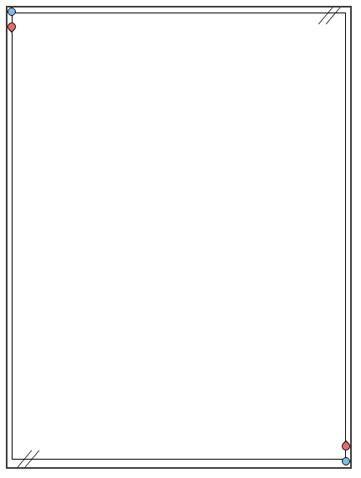
新初三暑假 | 英语必会
常用动词过去式及过去分词
1、A---A---A型
（现在式、过去式和过去分词同形）
动词原形（现在式） | 过去式 | 过去分词 | 词义
cost | cost |  | 花费
cut | cut |  | 割，切
hit | hit |  | 打
let | let |  | 让
put | put |  | 放下
read | read |  | 读
hurt | hurt |  | 伤
2、 A---A---B型
（现在式和过去式同形）
动词原形（现在式） | 过去式 | 过去分词 | 词义
beat | beat |  | 打
3、A---B---A型
（现在式和过去分词同形）
动词原形（现在式） | 过去式 | 过去分词 | 词义
come | came |  | 来
become | became |  | 变
run | ran |  | 跑
4、 A ---B ---B型
（1）在动词原形后加一个辅音字母d或t构成过去式或过去分词。
动词原形（现在式） | 过去式 | 过去分词 | 词义
burn | burnt |  | 燃烧
learn | learned/learnt |  | 学习
mean | meant |  | 意思
hear | heard |  | 听见
- 把动词原形的最后一个辅音字母“d”改为“t” 构成过去式或过去分词。
动词原形（现在式） | 过去式 | 过去分词 | 词义
build | built |  | 建筑
lend | lent |  | 借给
lose | lost |  | 失去
sent | sent |  | 送
spend | spent |  | 花费
（3）其他
动词原形（现在式） | 过去式 | 过去分词 | 词义
pay | paid |  | 付
lay | laid |  | 下蛋
say | said |  | 说
bring | brought |  | 带来
buy | bought |  | 买
think | thought |  | 想
sleep | slept |  | 睡
keep | kept |  | 保持
sweep | swept |  | 扫
stand | stood |  | 站
understand | understood |  | 明白
win | won |  | 得胜
shine | shone/shined |  | 发光
catch | caught |  | 抓住
teach | taught |  | 教
feel | felt |  | 觉得
fight | fought |  | 战斗
find | found |  | 发现
get | got |  | 得到
hang | hanged/hung |  | 绞死，挂
have | had |  | 有
hold | held |  | 盛，握
leave | left |  | 离开
make | made |  | 制造
meet | met |  | 遇见
sell | sold |  | 卖
shoot | shot |  | 射击
tell | told |  | 告诉

新初三暑假 | 英语必会
常用动词过去式及过去分词
1、A---A---A型
（现在式、过去式和过去分词同形）
动词原形（现在式） | 过去式 | 过去分词 | 词义
cost | cost |  | 花费
cut | cut |  | 割，切
hit | hit |  | 打
let | let |  | 让
put | put |  | 放下
read | read |  | 读
hurt | hurt |  | 伤
2、 A---A---B型
（现在式和过去式同形）
动词原形（现在式） | 过去式 | 过去分词 | 词义
beat | beat |  | 打
3、A---B---A型
（现在式和过去分词同形）
动词原形（现在式） | 过去式 | 过去分词 | 词义
come | came |  | 来
become | became |  | 变
run | ran |  | 跑
4、 A ---B ---B型
（1）在动词原形后加一个辅音字母d或t构成过去式或过去分词。
动词原形（现在式） | 过去式 | 过去分词 | 词义
burn | burnt |  | 燃烧
learn | learned/learnt |  | 学习
mean | meant |  | 意思
hear | heard |  | 听见
- 把动词原形的最后一个辅音字母“d”改为“t” 构成过去式或过去分词。
动词原形（现在式） | 过去式 | 过去分词 | 词义
build | built |  | 建筑
lend | lent |  | 借给
lose | lost |  | 失去
sent | sent |  | 送
spend | spent |  | 花费
（3）其他
动词原形（现在式） | 过去式 | 过去分词 | 词义
pay | paid |  | 付
lay | laid |  | 下蛋
say | said |  | 说
bring | brought |  | 带来
buy | bought |  | 买
think | thought |  | 想
sleep | slept |  | 睡
keep | kept |  | 保持
sweep | swept |  | 扫
stand | stood |  | 站
understand | understood |  | 明白
win | won |  | 得胜
shine | shone/shined |  | 发光
catch | caught |  | 抓住
teach | taught |  | 教
feel | felt |  | 觉得
fight | fought |  | 战斗
find | found |  | 发现
get | got |  | 得到
hang | hanged/hung |  | 绞死，挂
have | had |  | 有
hold | held |  | 盛，握
leave | left |  | 离开
make | made |  | 制造
meet | met |  | 遇见
sell | sold |  | 卖
shoot | shot |  | 射击
tell | told |  | 告诉

新初三暑假 | 英语必会
常用动词过去式及过去分词
1、A---A---A型
（现在式、过去式和过去分词同形）
动词原形（现在式） | 过去式 | 过去分词 | 词义
cost | cost | cost | 花费
cut | cut | cut | 割，切
hit | hit | hit | 打
let | let | let | 让
put | put | put | 放下
read | read | read | 读
hurt | hurt | hurt | 伤
2、 A---A---B型
（现在式和过去式同形）
动词原形（现在式） | 过去式 | 过去分词 | 词义
beat | beat | beaten | 打
3、A---B---A型
（现在式和过去分词同形）
动词原形（现在式） | 过去式 | 过去分词 | 词义
come | came | come | 来
become | became | become | 变
run | ran | run | 跑
4、 A ---B ---B型
（1）在动词原形后加一个辅音字母d或t构成过去式或过去分词。
动词原形（现在式） | 过去式 | 过去分词 | 词义
burn | burnt | burnt | 燃烧
learn | learned/learnt | learned/learnt | 学习
mean | meant | meant | 意思
hear | heard | heard | 听见
- 把动词原形的最后一个辅音字母“d”改为“t” 构成过去式或过去分词。
动词原形（现在式） | 过去式 | 过去分词 | 词义
build | built | built | 建筑
lend | lent | lent | 借给
lose | lost | lost | 失去
sent | sent | sent | 送
spend | spent | spent | 花费
（3）其他
动词原形（现在式） | 过去式 | 过去分词 | 词义
pay | paid | paid | 付
lay | laid | laid | 下蛋
say | said | said | 说
bring | brought | brought | 带来
buy | bought | bought | 买
think | thought | thought | 想
sleep | slept | slept | 睡
keep | kept | kept | 保持
sweep | swept | swept | 扫
stand | stood | stood | 站
understand | understood | understood | 明白
win | won | won | 得胜
shine | shone/shined | shone/shined | 发光
catch | caught | caught | 抓住
teach | taught | taught | 教
feel | felt | felt | 觉得
fight | fought | fought | 战斗
find | found | found | 发现
get | got | got | 得到
hang | hanged/hung | hanged/hung | 绞死，挂
have | had | had | 有
hold | held | held | 盛，握
leave | left | left | 离开
make | made | made | 制造
meet | met | met | 遇见
sell | sold | sold | 卖
shoot | shot | shot | 射击
tell | told | told | 告诉

